 YEAR 5 · FAIR OR UNFAIR? · TALK TOOLKIT
AI Watchdog Talk Desk Mat
Talk function | Support (full frame) | Core (starter) | Stretch (open reasoning)
Explaining | The AI was trained on ___, so it ___. | This happens because ___. | The main reason is ___, which means ___, so ___.
Agreeing and building | I agree with ___, and I'd add ___. | Building on ___'s idea, ___. | ___'s point links to ___ because ___, which suggests ___.
Challenging politely | I see it differently because ___. | That's a fair point, but the evidence suggests ___. | I'd challenge that, because if ___ then ___. What about ___?
Questioning | Who would ___? | What evidence do we have that ___? | What would happen if ___? Would it still be fair for ___?
Justifying with evidence | The evidence suggests ___ because ___. | My evidence is ___. This shows ___. | The strongest evidence is ___, because ___, although ___.
Comparing and weighing up | On one hand ___. On the other hand ___. | ___ is fairer than ___ because ___. | Although ___, I think ___ matters more because ___.
Summarising | Our group thinks ___. | To summarise our discussion, ___. | To summarise, most of us agreed ___, but ___ argued ___ because ___.
Reflecting | I used to think ___. Now I think ___. | I changed my mind when ___. | My thinking changed when ___ because ___. I'm still wondering ___.

Watchdog Talk Charter   Listen and link  Back it with evidence  Challenge with respect  Share the floor  Be open to changing your mind | Power words for AI  Say: was trained on · predicts · matches patterns · training data · works less well for · designed by people · people are responsible  Don't say: the AI thinks · knows · understands · wants · feels · is racist / mean · decides by itself
Word strip, frames by brief and talk routines
  training data |   label |   variety | success criteria | bias |   left out |   data centre |   e-waste | knock-on effect |   final say

  Brief 1: Train the Sorter  training data · label · variety · example  We chose ___ because it adds variety: it is ___. |   Brief 2: Testing, Testing  criterion · test set · fair test · score · evidence  It met the criterion ___ because ___. The evidence suggests ___. |   Brief 3: Not Built for Me  bias · unfair · left out · representative  This is unfair because ___. One way to fix it is ___.
  Brief 4: The Hidden Cost  data centre · energy · water · e-waste · benefit  On one hand ___. On the other hand ___. So I think ___. |   Brief 5: We Didn't Mean That!  intended · unintended · knock-on · privacy  An unexpected result could be ___, which means ___. |   Brief 6: Who Should Decide?  final say · responsible · motion · rebut  I believe ___. My evidence is ___. I disagree with ___ because ___.

Talk routine cards
Discussion roles  Builder, Challenger, Questioner, Summariser. Rotate roles. |   Envoys  Visit another group; bring back one idea. |   Fishbowl  Inner circle talks; outer circle observes and feeds back. |   Four corners  Move to your view; agree a reason; switch if convinced. | Conscience alley  Two lines give reasons; the walker decides. | Mini-debate  Open, rebut, question, sum up, vote.

Working wall: Watchdog Talk Charter
Listen and link  (Link two fingers like a chain)  Grows from: Listen to understand | Back it with evidence  (Tap your palm like a card)  Grows from: Give a reason | Challenge with respect  (Tilt a flat hand side to side)  Grows from: Challenge the idea, not the person | Share the floor  (Open palm towards someone quieter)  Grows from: Bring everyone in | Be open to changing your mind  (Turn your hand over)  Grows from: New for Year 5

Working wall: the four Watchdog Questions
Who is it for?  Who will use it, and what job is it designed to do? | Who could it leave out?  Who might it work less well for? |   What does it cost?  Energy, water, materials, time, learning, privacy | Who decides?  Which decisions must a person stay in charge of?

Working wall: discussion roles
BUILDER  Adds to an idea and links it to someone else's.  "Building on ___'s idea, ___." | CHALLENGER  Politely questions an idea and asks for evidence.  "That's a fair point, but ___." |   QUESTIONER  Asks questions that dig deeper.  "What evidence do we have that ___?" | 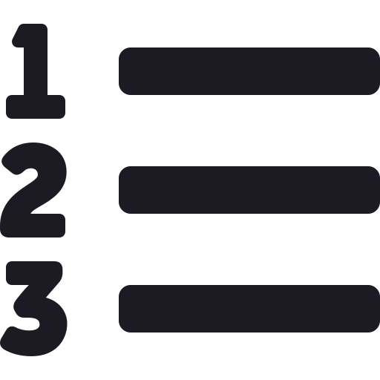  SUMMARISER  Pulls the discussion together at the end.  "To summarise our discussion, ___."

Working wall: the Fairness Scale and the six seals
  FAIR  Works well for everyone it affects. |   FAIR IF…  Only fair if something changes. |   UNFAIR  Leaves people or the planet worse off.

Brief 1  Data Designer | Brief 2  Test Setter | Brief 3  Fairness Finder | Brief 4  Planet Protector | Brief 5  Ripple Spotter | Brief 6  Final Say

Adapted from: OECD / European Union (2026), "Empowering learners for the age of AI: An AI literacy framework for primary and secondary education", https://doi.org/10.1787/65cd27d4-en (CC BY 4.0). This is an adaptation of an original work by the OECD and the European Union. The opinions expressed and arguments employed in this adaptation should not be reported as representing the official views of the OECD, its Member countries or the European Union.
Icons: Font Awesome Free (CC BY 4.0), game-icons.net (CC BY 3.0), Phosphor and Lucide (MIT/ISC), Material Design Icons (Apache 2.0). No AI-generated images are used.

