 YEAR 5 · FAIR OR UNFAIR? · LESSON 5 OF 6
Watchdog Brief 5: We Didn't Mean That!
Key question: What happens when AI has unexpected effects?

Lesson at a glance
Learning objective | To identify unintended consequences of AI use that differ from what the user wanted, and suggest how designers and users could reduce them.
Success criteria | - I can explain the difference between what a user intended and an unintended consequence.  - I can map first effects and knock-on effects of an AI use on a consequence wheel.  - I can suggest a change a designer or user could make to reduce a harmful consequence.  - Oracy (Physical): I can use my voice (tone, volume and pace) and body language to make my point persuasive in the conscience alley.
AILit Framework | EA7 Intermediate (focus): Analyse how well the use of an AI system aligns with ethical principles and human values. Identify unintended consequences of AI use that differ from what the user wanted. · EA4 (link) recommendations shaping choices; SA4 (preview) improving a design for wellbeing.  Knowledge: K1.4 (many types of AI, some hidden), K4.1 (AI's influence on decisions and agency), K4.3 (responsible design) · Skills: Critical Thinking, Problem Solving, Self & Social Awareness · Attitudes: Reflective, Responsible · Level: Intermediate (builds on Y3 EA7 Basic)
National Curriculum | Computing KS2: use technology safely, respectfully and responsibly; recognise acceptable and unacceptable behaviour; identify a range of ways to report concerns about content and contact.  Computing KS2: be discerning in evaluating digital content.  RSHE (Health Education, primary; statutory guidance 2025, in force September 2026): internet safety and harms, including the benefits of rationing time spent online and how information online is ranked, selected and targeted.  English (reading, link): King Midas, a traditional myth, as a model of unintended consequences.  English, spoken language (Y1–6): articulate and justify answers, arguments and opinions; participate in discussions, presentations, performances, role play, improvisations and debates; consider and evaluate different viewpoints, attending to and building on the contributions of others; use spoken language to develop understanding through speculating, hypothesising, imagining and exploring ideas; gain, maintain and monitor the interest of the listener(s).  2028-ready: anticipates the new Computing strands on AI and data awareness, and digital literacy and responsible use (draft programmes of study not found published when rechecked on 6 October 2026).
Trust values | Social responsibility (unit focus) · Self-responsibility (choosing how I use AI) · Caring for others (family privacy, wellbeing)
Timing | 60 minutes (45-minute timings are in the sequence; see also Adaptive teaching)
AI access | None for pupils. Unplugged by default. Optional teacher-only demo (slide 8): a rehearsed homework-helper request on a Trust-approved tool, signed in with a Trust account, no personal data, shown and labelled "AI-generated". A printed example is provided if you don't demo.
Safeguarding | Low to medium risk. Scenarios touch on privacy at home, screen time and in-app purchases; pupils may disclose home device use. Respond neutrally; pass any concern to the DSL. No live smart speakers in class.

Teacher subject knowledge
Written for non-specialists. Read before teaching (about 5 minutes).
- Intended vs unintended (EA7, K4.1): people use AI for a purpose (intended). AI can also cause effects nobody wanted (unintended consequences): some appear straight away (first effects) and some later or further away (knock-on effects). EA7 at Intermediate asks pupils to spot these and judge them against values such as learning, privacy, wellbeing and fairness.
- King Midas (a traditional Greek myth, public domain) is the hook: he got exactly what he asked for, and it went wrong. Like an AI tool, the wish did what it was asked, not what he really needed.
- Homework helper: generative AI can produce a finished answer in seconds. The intended effect (finish quickly) can undermine the real purpose of homework (learning) and hide what a pupil needs help with. AI answers can also be wrong (EA3). In Year 6 pupils meet the simple "No AI / AI helper / AI allowed" scale.
- Always-listening speakers: smart speakers listen for a wake word; they can activate by mistake and recordings may be stored by the company. Young children may treat them as people (EA2, KCSIE contact risk for human-like AI). Don't run a live speaker in class.
- Recommenders and screen time (EA4 link): recommendation and "autoplay" features are designed to keep people engaged. Unintended effects include longer screen time, less sleep and nudges to spend money (KCSIE commerce). RSHE Health Education covers the benefits of rationing time online.
- Designers and users both have choices (K4.3): designers can add break reminders, hint-not-answer modes, mute buttons and lights, clear privacy settings, and no pressure to buy. Users can set limits, check privacy settings with an adult, and use AI as a helper rather than a replacement.
- Optional teacher demo: rehearse first. Prompt: "Write a short paragraph explaining why volcanoes erupt, for a 10-year-old." Check the output for accuracy, label it "AI-generated (teacher demo)" and use it only to show speed. No pupil names or data.

Before the lesson
☐ Print the Midas story card (Appendix A) and scenario cards (Appendix B)
☐ Print consequence wheels (Appendix C) on A3 if possible, one per group
☐ Print conscience alley cards (Appendix D) and the Fix-It design card (Appendix E)
☐ Print talk frame cards (Appendix F) and exit tickets (Appendix G)
☐ Clear a space for two lines of pupils (the conscience alley)
☐ Optional: rehearse the teacher demo on a Trust-approved tool and keep a printed, labelled copy as backup

Key vocabulary
Gestures: intended = point straight ahead; unintended = point ahead, then curve your finger away; knock-on = one fist bumping the other.
Word | Child-friendly meaning
intended | What someone meant or wanted to happen.
unintended consequence | A result nobody meant to happen.
knock-on effect | Something that happens later because of an earlier effect.
user / designer | The person using a tool / the people who made it.
privacy | Keeping information about yourself and your family safe and in your control.
screen time | Time spent looking at screens.
wellbeing | Feeling healthy, happy and safe.

Common misconceptions
Pupils may think… | Actually… | Try saying…
If the user wanted something good, nothing bad can happen. | Good intentions can still have unexpected effects. | "Did King Midas want anything bad?"
The AI meant to cause harm. | AI doesn't mean anything. It does what it was designed or asked to do. | "Who designed it to keep you playing?"
Unintended effects are always bad. | Some are good (e.g. finding a new hobby), but watchdogs look hardest at harmful ones. | "Was there a good surprise too?"
Only the user can fix it. | Designers make choices too: break reminders, mute buttons, hint modes. | "What could the designer change?"
A smart speaker only listens when you talk to it. | It listens all the time for its wake word and can switch on by mistake. | "How does it know when you've said its name?"

Resources
- Slides: Y5-L5-slides.pptx (16 slides, with speaker notes)
- Appendix A: King Midas story card
- Appendix B: scenario cards (A, B, C)
- Appendix C: consequence wheel (A3)
- Appendix D: conscience alley cards
- Appendix E: Fix-It design card
- Appendix F: talk frame cards
- Appendix G: exit tickets
- Optional: Trust-approved AI tool for the teacher demo, with a printed labelled backup

Lesson sequence
Teacher script is in italics. Timings show 60-minute / 45-minute versions.
Phase | Teacher does and says | Pupils do | Talk and AfL
1. Hook: the golden wish  0–7 / 0–5 min  Slides 1–3 | Slide 2: tell the King Midas story dramatically (Appendix A). Pause before the food and his daughter: "Predict what happens next."  Slide 3: what he intended vs what happened. "AI can be like Midas's wish: it does what it's asked, not always what we really need." | Predict; then sort intended vs unintended with a partner. | "He wanted ___, but an unexpected result was ___."  AfL: can pupils separate intention from consequence?
2. Consequence wheels explained  7–15 / 5–10 min  Slides 4–8 | Mission (slide 4). Charter focus Listen and link (slide 5): the alley only works if Sam really listens.  Key words (slide 6).  Slide 7: model a consequence wheel: the AI use in the middle → first effects → knock-on effects.  Slide 8 (optional): rehearsed, labelled homework-helper demo, or show the printed example. "It took 5 seconds. What did Sam learn?" | Gesture along; suggest a knock-on effect for the model wheel. | Hinge: "Sam finished faster. Is that a first effect or a knock-on effect?" (First.)
3. Map the ripples  15–30 / 10–21 min  Slides 9–11 | Slide 9: three scenarios. Groups take one each (Appendix B) and complete a consequence wheel (Appendix C): at least 4 first effects and 4 knock-on effects, coloured green (good) or red (harmful).  Model the frames (slide 11).  Circulate: "And then what? Who else is affected?" | Complete the wheel; star the most serious harmful effect. | "An unexpected result could be ___, which means ___."  AfL: are knock-on effects really knock-on (caused by a first effect)?
4. Conscience alley  30–46 / 21–33 min  Slides 12–13 | Slide 12: explain the alley. Two lines face each other. One line gives reasons to use the AI that way; the other gives reasons to think again. Model a voice: "Sam, you'll be finished in seconds. You'll have time for football!" vs "But Sam, if you don't do it yourself, how will you know it when there's a test?"  Slide 13: run alley 1 (Sam and the homework helper) and alley 2 (Leo and "one more level" at bedtime). Volunteers walk slowly; each pupil speaks as they pass.  The walker decides and explains. | Prepare one line with a partner; deliver it with voice and body language as the walker passes.  Walker decides and gives the strongest reason. | Alley frames (slide 13).  AfL: physical strand: tone, volume, eye contact, pace.
5. Design a fix  46–54 / 33–40 min  Slide 14 | Slide 14: groups return to their scenario. Choose one designer fix and one user fix that would reduce the starred harm (Appendix E). Apply the Watchdog Questions. | Complete the Fix-It card; share one fix with the class. | "A designer could ___ so that ___."  AfL: does the fix target the starred harm?
6. Plenary  54–60 / 40–45 min  Slides 15–16 | Exit ticket and seal (slide 15). Preview the final brief, the debate (slide 16). Pupils choose their debate side for next lesson (pupil voice). | Exit ticket and talk check.  Choose a debate side. | Oracy self-check: did I use my voice to persuade?

Talk toolkit for this lesson
Talk routine: Conscience alley. Two lines face each other. As a classmate (in role as a character facing a decision) walks slowly down the alley, each pupil speaks one reason: one line for, one line against. The walker decides and explains which reason was strongest
Oracy focus: Physical (varying tone, volume and pace; eye contact and gesture to make a point persuasive). Upper KS2 strand: vary tone and pace when presenting.
Teacher model: Line 1 (upbeat, quick): "Sam, you'll be finished in seconds. More time for football!" Line 2 (calm, slower, eye contact): "But Sam, if you don't do it yourself, how will you know it when there's a test?" Walker: "I've decided to use it only for hints, because the strongest reason I heard was that I need to learn it myself."
Function / level | Sentence frames
Explaining: support | An unexpected result could be ___, which means ___.  Word bank: intended · unexpected · consequence · knock-on · learn · privacy · screen time · sleep · designer · user
Explaining: core | The user wanted ___, but an unexpected result could be ___, which means ___.
Explaining: stretch | Although ___ was intended, a knock-on effect could be ___, which matters because ___. A designer could ___.
Alley: for | You should ___ because ___.
Alley: against | But if you do, ___ might happen, because ___.
Deciding (walker) | I've decided to ___ because the strongest reason I heard was ___.
Designing a fix | A designer could ___ so that ___. A user could ___.

Adaptive teaching
Pathway | Adaptations
Support | - Scenario A only, with pre-written effect cards to place on the wheel  - Wheel with 2 first effects and 2 knock-on effects  - Alley: read a line from a card; partner speaks with you  - Support frame and word bank
Core | As planned.
Stretch | - Find a GOOD unintended effect as well as a harmful one, and weigh them up  - Link scenario C to Lesson 4: what does "one more level" cost the planet?  - Write the walker's decision speech using "Although…"
SEND | - The alley can be done seated in two rows; the walker can be a puppet moved along the line  - Warn pupils before the alley (noise, closeness); offer a scribe or observer role  - Visual consequence wheel with symbols  - AAC: preload "learn", "privacy", "sleep", "because"
EAL | - Picture-supported scenario cards  - Rehearse the alley line with a partner first  - Key words with gestures; dual-language word bank
Tech access | - None (default): fully unplugged, using the printed example  - Teacher demo (optional): rehearsed homework-helper request on a Trust-approved tool, labelled AI-generated, no personal data  - Pupil hands-on: not applicable (KS2)
45-minute version | - Skip the demo  - One scenario as a whole class on the board  - One conscience alley only

Optional extension for computing specialists
Discuss engagement metrics: designers measure time spent and clicks, so recommenders are tuned to increase them. What would you measure instead to support wellbeing?
Explain a wake word detector: a small model on the device listens continuously for one sound pattern before sending audio to the cloud.

Assessment
Unit "I can" statement (from the progression map): I can identify unintended consequences of AI use that differ from what the user wanted (EA7 Intermediate).
Judgement | What to look for
Working towards | Names one unexpected effect with support; may mix up intended and unintended.
Expected | Distinguishes intended from unintended effects, maps first and knock-on effects, and suggests a fix.
Greater depth | Explains knock-on effects for different people (family, friends, the planet), weighs good and harmful effects, and gives designer AND user fixes.
Oracy | Uses tone, volume, pace and body language to make a point persuasive (physical).

Model answer
"Sam wanted to finish homework quickly. An unexpected result could be that Sam learns less, which means the teacher can't see what Sam finds hard and the test feels harder later. A designer could make the helper give hints instead of answers, so Sam still does the thinking."

Safeguarding notes
- Low to medium risk. Scenarios cover privacy at home (smart speakers), screen time and in-app purchases (KCSIE 2026 commerce), and children treating AI as a person (contact).
- Pupils may mention devices, games or apps they use at home, some of which are for older ages. Respond neutrally, don't ask pupils to list their apps, and focus on safe choices and trusted adults. Pass any concern (e.g. excessive gaming affecting sleep, spending money, unsafe contact) to the DSL.
- Don't run a live smart speaker in class. Any teacher demo uses a Trust-approved tool and a Trust account, contains no personal data, is rehearsed and checked first, and is labelled "AI-generated".
- The conscience alley involves standing close together: agree respectful behaviour, and offer alternatives for pupils who find it uncomfortable.

Appendix A: King Midas story card
A retelling of a traditional Greek myth (public domain).
King Midas loved gold more than anything. One day he was granted a wish. "I wish," he said, "that everything I touch turns to gold!"
At first it was wonderful. He touched a twig: gold. A stone: gold. A rose: gold!
Then he felt hungry. He picked up some bread… and it turned to hard, cold gold. He lifted a cup of water… gold. He couldn't eat or drink.
When his daughter ran to hug him, she turned into a golden statue. Midas wept. He had got exactly what he asked for, but not what he really needed.
In the end he begged for the wish to be taken away, and washed the golden touch away in a river.

Appendix B: Scenario cards
One per group. The intended effect is given; pupils find the unintended ones. Teacher ideas are at the bottom.

A: The Homework Helper
Sam uses an AI homework helper so that homework gets finished quickly.
Intended: Finish homework faster
Unintended consequences: ?

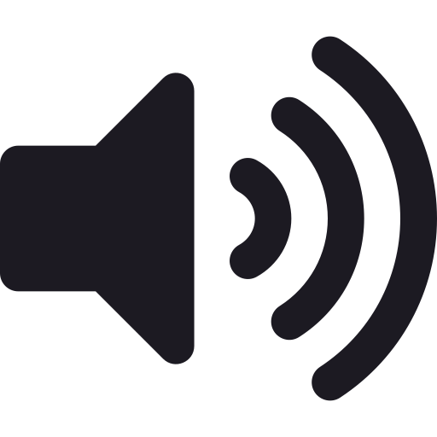
B: The Always-Listening Speaker
Riya's family buys a smart speaker to play music and set timers.
Intended: Handy help around the house
Unintended consequences: ?


C: The Game Recommender
Leo's game app uses AI to suggest the next game or level he'll enjoy.
Intended: Help Leo find games he likes
Unintended consequences: ?

Teacher ideas
Scenario | Possible unintended consequences
A: The Homework Helper | Sam learns less · The teacher can't see what Sam finds hard · The AI might be wrong and Sam copies the mistake · Tests feel harder later
B: The Always-Listening Speaker | It listens all the time for its wake word · It can record conversations by mistake · A company stores information about the family · Little brother talks to it as if it's a person
C: The Game Recommender | "One more level" turns into hours · Less sleep; less time outside or with friends · Pop-ups suggest buying extra lives · Leo only sees the same kind of game

Appendix C: Consequence wheel
Print on A3. Write the AI use in the middle, first effects in the next ring, knock-on effects in the outer ring. Colour good effects green and harmful ones red. Star the most serious harm.
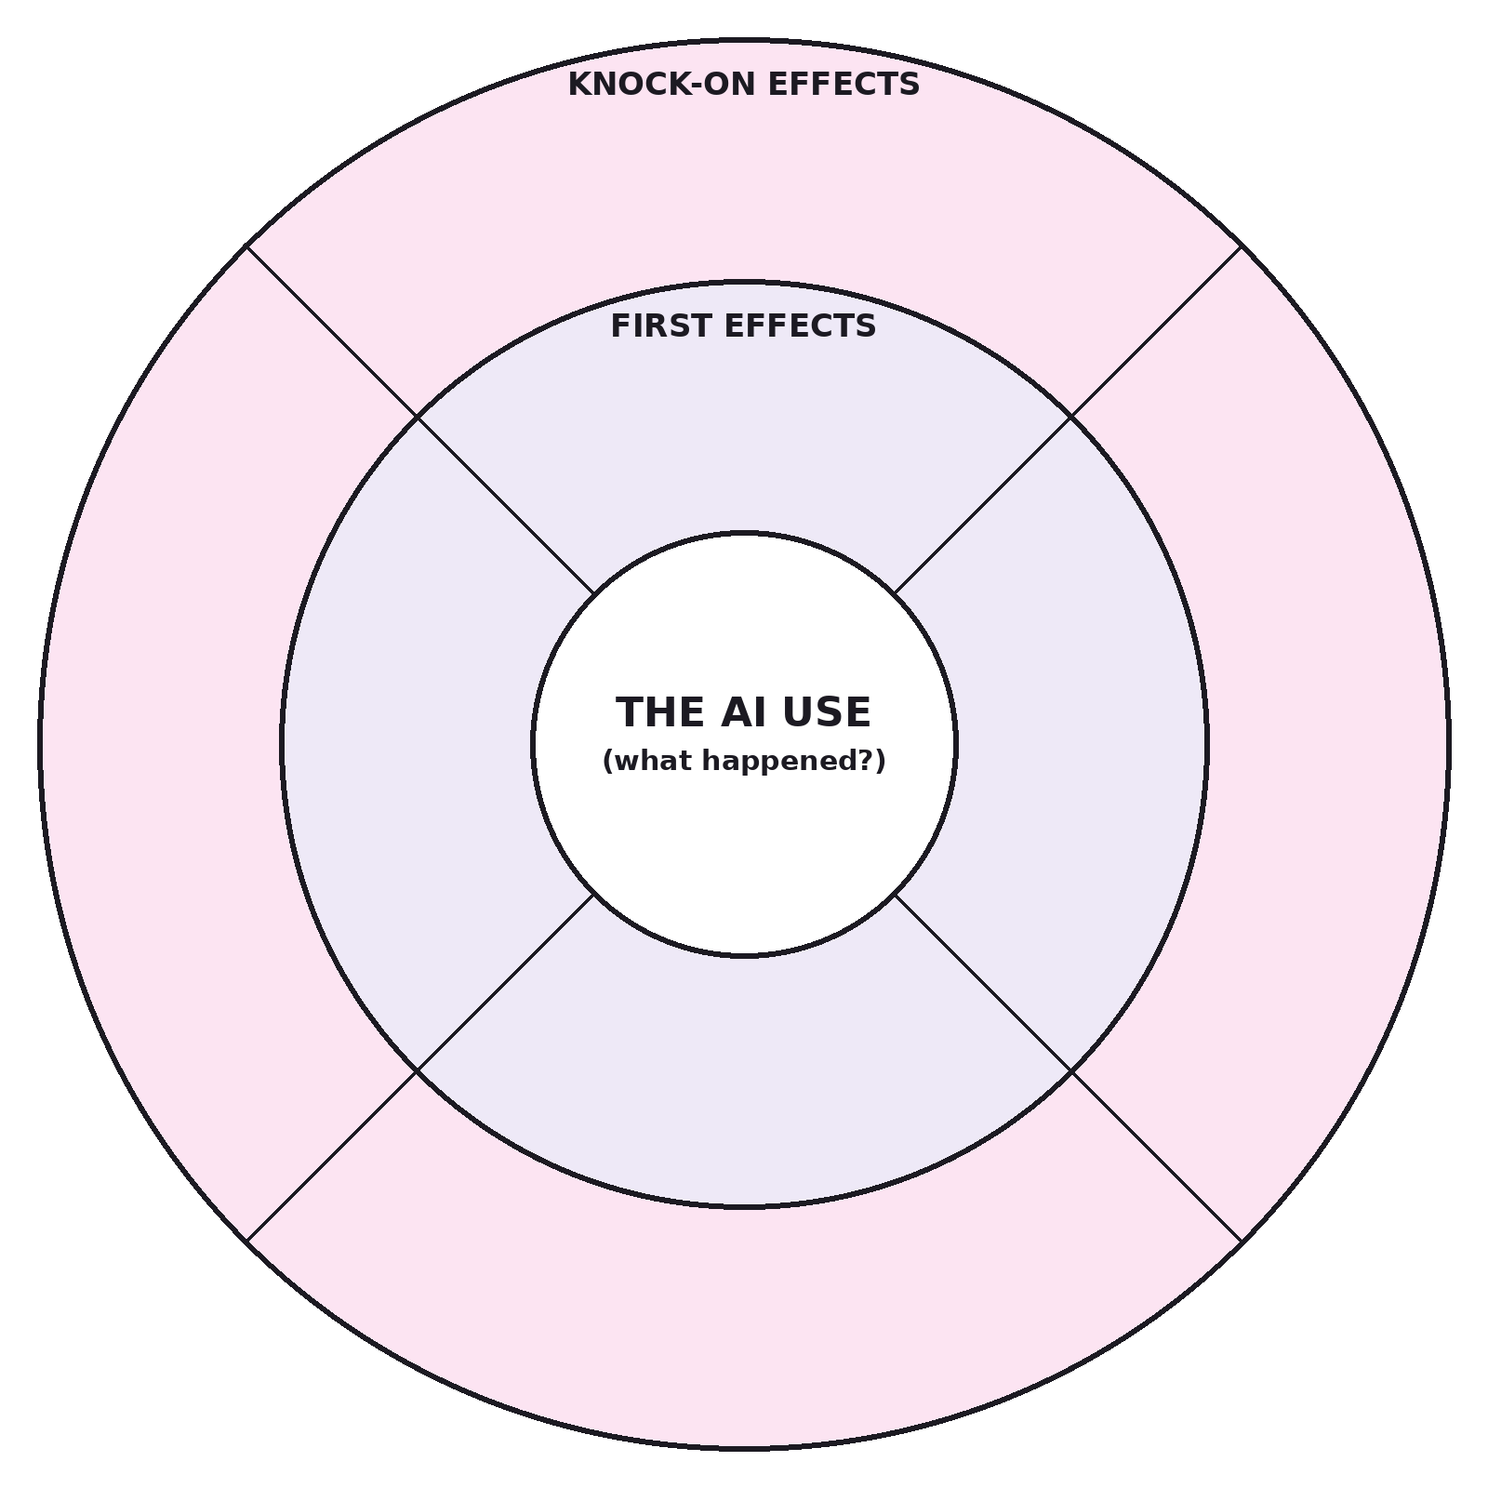

Our AI use: ___________________________________ Most serious harm (★): ___________________________________

Appendix D: Conscience alley cards
Line 1 gives reasons FOR; line 2 gives reasons to THINK AGAIN.
Alley 1 · Walker  Sam: "Should I let the AI homework helper do ALL my homework?" | Alley 2 · Walker  Leo, at bedtime: "The app says 'One more level?' Should I keep playing?"

Line 1 (for) prompts  It's faster · More free time · It's easy · Everyone uses it · It's fun | Line 2 (think again) prompts  Will you learn it? · What if it's wrong? · Sleep · Time with friends · Who designed it to keep you playing?

Support: full frame + word bank
You should ___ because ___.
But if you do, ___ might happen, because ___.
Word bank: faster · learn · wrong · sleep · friends · designed · choice · later
Core: sentence starters
You should ___, because ___.
But think about ___, because ___.
Stretch: open reasoning
I've decided to ___ because the strongest reason I heard was ___.
Although ___, the strongest reason is ___ because ___.

Appendix E: Fix-It design card
One per group.
Our scenario
Most serious harm (★)
A designer could… so that…
A user could… so that…
Watchdog Questions: who is it for? who could it leave out? what does it cost? who decides?

Appendix F: Talk frame cards
Support: full frame + word bank
An unexpected result could be ___, which means ___.
Word bank: intended · unexpected · consequence · knock-on · learn · privacy · screen time · sleep · designer · user
Core: sentence starters
The user wanted ___, but an unexpected result could be ___, which means ___.
A designer could ___ so that ___.
Stretch: open reasoning
Although ___ was intended, a knock-on effect could be ___, which matters because ___. A designer could ___.

Appendix G: Watchdog Report exit tickets
WATCHDOG REPORT · BRIEF 5 · SEAL: RIPPLE SPOTTER
Name: ___________________________
1. What is an unintended consequence? ______________________________________________
2. Choose a scenario (A, B or C). An unexpected result could be ___, which means ___.
______________________________________________________________________________________
3. A designer could ___ so that ___.
______________________________________________________________________________________
Talk check: I used my voice and body language to persuade ☐

WATCHDOG REPORT · BRIEF 5 · SEAL: RIPPLE SPOTTER
Name: ___________________________
1. What is an unintended consequence? ______________________________________________
2. Choose a scenario (A, B or C). An unexpected result could be ___, which means ___.
______________________________________________________________________________________
3. A designer could ___ so that ___.
______________________________________________________________________________________
Talk check: I used my voice and body language to persuade ☐

Adapted from: OECD / European Union (2026), "Empowering learners for the age of AI: An AI literacy framework for primary and secondary education", https://doi.org/10.1787/65cd27d4-en (CC BY 4.0). This is an adaptation of an original work by the OECD and the European Union. The opinions expressed and arguments employed in this adaptation should not be reported as representing the official views of the OECD, its Member countries or the European Union.
Icons: Font Awesome Free (CC BY 4.0), game-icons.net (CC BY 3.0), Phosphor and Lucide (MIT/ISC), Material Design Icons (Apache 2.0). No AI-generated images are used.

