 YEAR 5 · FAIR OR UNFAIR? · LESSON 3 OF 6
Watchdog Brief 3: Not Built for Me
Key question: Why does AI sometimes work worse for some people?

Lesson at a glance
Learning objective | To explain how unrepresentative training data can make AI work less well for some people, and why that is unfair.
Success criteria | - I can explain why ShoeSpotter failed, using the words "training data" and "left out".  - I can retell the key facts of Joy Buolamwini's discovery accurately.  - I can suggest ways to make an AI system fairer and explain why they would help.  - Oracy (Cognitive): I can build on or challenge an idea in the fishbowl, using evidence from the story.
AILit Framework | EA6 Intermediate (focus): Explain how AI could be used to amplify societal biases. Explain how unrepresentative data can make AI work less well for some people (e.g. face recognition), and why that is unfair. · SA3 (b) and SA2 (b) revisits: varied data and testing with everyone.  Knowledge: K2.1 (human choices in design and data), K2.5 (bias), K4.1 (AI decisions affect people fairly or unfairly) · Skills: Critical Thinking, Self & Social Awareness · Attitudes: Empathetic, Responsible · Level: Intermediate (builds on Y2 EA6 Basic)
National Curriculum | Computing KS2: be discerning in evaluating digital content.  Computing KS2: use logical reasoning to explain how some simple algorithms work and to detect and correct errors in algorithms and programs.  RSHE (Relationships Education, primary): respectful relationships, including the importance of respecting others even when they are very different from them, and the conventions of courtesy and manners.  English, spoken language (Y1–6): articulate and justify answers, arguments and opinions; participate in discussions, presentations, performances, role play, improvisations and debates; consider and evaluate different viewpoints, attending to and building on the contributions of others; use spoken language to develop understanding through speculating, hypothesising, imagining and exploring ideas; gain, maintain and monitor the interest of the listener(s).  2028-ready: anticipates the new Computing strands on AI and data awareness, and digital literacy and responsible use (draft programmes of study not found published when rechecked on 6 October 2026).
Trust values | Equity and Equality (unit focus: systems should work well for everyone) · Caring for others · Openness (speaking up, like Joy)
Timing | 60 minutes (45-minute timings are in the sequence; see also Adaptive teaching)
AI access | None. Fully unplugged. No teacher demo: never demonstrate face detection or upload anyone's photo. No images of real faces are used anywhere in this lesson (icons only).
Safeguarding | DSL heads-up recommended. The lesson discusses skin colour and unfair treatment; pupils may share experiences of racism. Follow your behaviour and anti-racism procedures. No images of real faces.

Teacher subject knowledge
Written for non-specialists. Read before teaching (about 5 minutes).
- Bias in AI (EA6, K2.5): when an AI system works better for some groups of people than others. A common cause is unrepresentative training data: some people (or things) were left out or were only a small part of the examples. The AI isn't "mean" or "racist"; it matches patterns in the data people chose. But the effect can still be unfair, and people are responsible for fixing it.
- ShoeSpotter (hook): a pretend lost-property robot trained only on trainers. It learned "shoe = laces and a thick rubber sole", so it says NOT A SHOE to wellies, sandals and slippers. It's a safe, concrete model of the real story.
- The real story (facts checked against published sources, October 2026): Dr Joy Buolamwini is a computer scientist. As a graduate student at the MIT Media Lab she built an art project (the "Aspire Mirror") that used face-detection software, which did not detect her face until she held up a white mask. In 2018 she and Timnit Gebru published the Gender Shades study, testing commercial face-analysis systems (IBM, Microsoft, Face++) on classifying faces as male or female. Error rates were up to about 34.7% for darker-skinned women and under 1% for lighter-skinned men. Common benchmark photo collections were mostly lighter-skinned faces. After publication, companies including IBM and Microsoft improved their systems. She founded the Algorithmic Justice League (2016) and wrote Unmasking AI (2023).
- Pitching it for Year 5: the slides say "sort photos of people's faces" rather than "classify gender". If pupils ask, explain simply that the systems were asked to guess whether a face was a man or a woman. Keep the focus on data and fairness.
- Language: use "darker skin" and "lighter skin". Never ask pupils to compare their own skin or faces, and don't single out any pupil. Say "the system worked less well for…", not "it didn't like…".
- Fixes: more varied training data; testing with everyone before use (Lesson 2); asking the people affected; being honest about what a system can't do; a person checking important decisions (Lesson 6). Not using a system until it works fairly is also an option.
- Don't role-play or hot-seat Joy Buolamwini (she is a real person). Pupils discuss her published work.

Before the lesson
☐ Give your DSL (and inclusion or anti-racism lead) a heads-up about the lesson content
☐ Print ShoeSpotter cards (Appendix A), one set per group, plus one large set for the hook
☐ Print story cards (Appendix B), one set per group
☐ Print fishbowl observer sheets (Appendix C) and question cards (Appendix D)
☐ Print Fix-It plans (Appendix E), talk frame cards (Appendix F) and exit tickets (Appendix G)
☐ Arrange chairs: an inner circle of 6 and an outer circle

Key vocabulary
Gestures: bias = tip one hand lower than the other; left out = sweep a hand outwards; representative = draw a big circle round everyone.
Word | Child-friendly meaning
bias (in AI) | When an AI system works better for some people than for others.
unfair | Treating people differently in a way that isn't right.
representative data | Training data that includes all the different people or things the AI will meet.
left out | Missing from the training data, or only a tiny part of it.
face detection | Software that finds faces in a photo or video.
works less well for | Makes more mistakes for some people.
responsible | In charge of putting something right.

Common misconceptions
Pupils may think… | Actually… | Try saying…
The AI is racist / mean. | AI doesn't have feelings or opinions. It matches patterns in data people chose, but the result can still be unfair. | "What was in its training data? Who chose it?"
It's nobody's fault, so it doesn't matter. | People design, train and test AI, so people are responsible for fixing unfair results. | "Who could have tested it with everyone?"
More photos always fixes it. | More of the same photos doesn't help. It needs variety and testing with everyone. | "Would 1,000 more trainers help with wellies?"
Bias only happens with faces. | Any AI trained on unrepresentative data can work worse for some people (voices, accents, shoes, recycling). | "Who could SortBot leave out?"
This was fixed, so it's over. | Joy's work helped, but checking for bias has to happen with every new system. | "Why do watchdogs keep checking?"

Resources
- Slides: Y5-L3-slides.pptx (16 slides, with speaker notes)
- Appendix A: ShoeSpotter training and test cards
- Appendix B: Joy Buolamwini story cards (no images of faces)
- Appendix C: fishbowl observer sheet
- Appendix D: fishbowl question cards
- Appendix E: Fix-It plan with the Fairness Scale
- Appendix F: talk frame cards
- Appendix G: exit tickets
- Optional: a real welly and trainer for the hook

Lesson sequence
Teacher script is in italics. Timings show 60-minute / 45-minute versions.
Phase | Teacher does and says | Pupils do | Talk and AfL
1. Hook: ShoeSpotter  0–7 / 0–5 min  Slides 1–3 | Slide 2: meet ShoeSpotter, the school's (pretend) lost-property robot. Show its 8 training photos: all trainers.  Slide 3: teacher in role as ShoeSpotter. Hold up each test card: "Wellies… NOT A SHOE. Sandals… NOT A SHOE." Pupils predict before each one.  "Whose lost shoes will never get back to them?" | Predict ShoeSpotter's answer for each card (thumbs).  Talk partners: why did it fail? | "I predict ShoeSpotter will say ___ because its training data ___."  AfL: listen for "it only saw trainers".
2. Why did it fail?  7–14 / 5–10 min  Slides 4–7 | Mission (slide 4); Charter focus Challenge with respect (slide 5).  Key words with gestures (slide 6).  Slide 7: data → pattern → result. "ShoeSpotter wasn't being mean. The data left people out, and people chose the data." Introduce bias. | Gesture along; mini-whiteboards: "ShoeSpotter worked less well for ___ because ___." | Hinge: "Would 1,000 more trainer photos fix ShoeSpotter?" (No: it needs variety.)
3. A true story  14–24 / 10–17 min  Slides 8–9 | Slides 8–9: tell Joy Buolamwini's story calmly and factually, using the six story cards. No images of faces.  Groups re-order shuffled story cards (Appendix B) and retell it to each other.  "What's the same as ShoeSpotter? What's different, and why does it matter more?" (Real people; phones, photos, security.) | Order the story cards; retell in turns; spot the link to ShoeSpotter. | "This is like ShoeSpotter because ___. It matters more because ___."  AfL: can pupils give the cause (data) and the effect (more mistakes for some people)?
4. Fishbowl  24–42 / 17–31 min  Slides 10–12 | Slide 10: explain the fishbowl. Six pupils in the inner circle (two Builders, two Challengers, a Questioner, a Summariser); everyone else observes and tallies builds and challenges (Appendix C).  Model the frames (slide 11).  Slide 12: run two rounds of 5 minutes on the question cards, swapping inner and outer circles. Observers give one piece of feedback each round. | Inner circle discusses; outer circle observes and tallies, then gives feedback.  Swap and repeat. | Builder and challenger frames (tiered).  AfL: are challenges backed with evidence from the story?
5. Fix it  42–52 / 31–38 min  Slide 13 | Slide 13: five fixes. Groups choose the two best for ShoeSpotter and for the face systems, justify them on the Fix-It plan (Appendix E), and place each system on the Fairness Scale: fair / fair if… / unfair. | Choose and justify two fixes; use the Fairness Scale. | "One way to fix it is ___ because ___."  AfL: do fixes match the cause (data, testing)?
6. Plenary: who could it leave out?  52–60 / 38–45 min  Slides 14–16 | Slide 14: Watchdog Question 2. "Who could OUR SortBot leave out? Who could a voice assistant leave out?" (e.g. people with different accents or speech).  Exit ticket and seal (slide 15). Preview Lesson 4 (slide 16). | Apply Watchdog Question 2 to a new system.  Exit ticket and talk check. | "___ could be left out because ___."  Oracy self-check: did I build or challenge with evidence?

Talk toolkit for this lesson
Talk routine: Fishbowl with builder and challenger roles. An inner circle of six discusses while the outer circle observes, tallies builds and challenges, and gives feedback. Circles swap after 5 minutes. Roles: two Builders, two Challengers, a Questioner and a Summariser
Oracy focus: Cognitive (building on and challenging ideas with evidence; reasoning about cause and effect). Upper KS2 strand: justify opinions with evidence; respond respectfully to disagreement.
Teacher model: Builder: "Building on Sam's idea that the photos were mostly lighter-skinned faces, that's just like ShoeSpotter only seeing trainers." Challenger: "That's a fair point, but the evidence suggests it matters more here, because people use face systems to unlock phones, so some people get locked out."
Function / level | Sentence frames
Explaining: support | This is unfair because ___ was left out of the training data.  Word bank: unfair · left out · training data · variety · works less well for · test · everyone · fix · responsible
Building: core | Building on ___'s idea, ___.
Challenging: core | That's a fair point, but the evidence suggests ___.
Fixing | One way to fix it is ___. This would help because ___.
Stretch (open reasoning) | I'd challenge that, because if ___ then ___. A fairer design would ___.
Questioning | Who should have tested it? What evidence would show it's fair now?
Summarising | To summarise our discussion, ___.

Adaptive teaching
Pathway | Adaptations
Support | - Three story cards instead of six (1, 4, 6), with picture symbols  - Pre-teach "bias", "left out" and "training data"  - Support frame and word bank; observer role in the fishbowl first  - Fix-It plan as a choose-and-tick sheet
Core | As planned.
Stretch | - Explain why "fewer than 1 in 100" vs "about 1 in 3" is such a big difference (fractions or percentages)  - Questioner card: "Should a system be used before it has been tested on everyone?"  - Think of a non-face example where data could leave people out (voices, accents, left-handed users)
SEND | - Physical shoes (welly, trainer, slipper) for the hook  - Fishbowl: offer a fixed role with a script card; allow observer-only participation  - Story cards read aloud by an adult; visual sequence strip  - Prepare pupils who may find discussions of difference upsetting; a quiet signal to step out
EAL | - Picture-supported story cards; key words in home language  - Rehearse builder and challenger frames with a partner before the fishbowl  - Gestures for bias, left out and representative
Tech access | - None (default): fully unplugged  - No teacher demo: never demonstrate face detection or upload photos of anyone  - Pupil hands-on: not applicable (KS2)
45-minute version | - Hook with three test cards  - Tell the story from the slides only (skip the card sort)  - One fishbowl round; fixes discussed orally

Optional extension for computing specialists
Introduce error rate: mistakes out of 100. Compare 1 in 100 (1%) with 1 in 3 (about 33%).
Discuss why we test separately for different groups: an overall score of 95% can hide a group for whom it works badly (link to Lesson 2's success criteria).

Assessment
Unit "I can" statement (from the progression map): I can explain how unrepresentative data can make AI work less well for some people (e.g. face recognition), and why that is unfair (EA6 Intermediate).
Judgement | What to look for
Working towards | Says ShoeSpotter or the face systems "didn't work for some people"; needs support to link this to training data.
Expected | Explains that people were left out of the training data, so the system made more mistakes for them, and why that is unfair.
Greater depth | Explains that people are responsible, compares the harms of different systems, and justifies fixes that match the cause.
Oracy | Builds on or challenges an idea with evidence from the story (cognitive).

Model answer
"The face-analysis systems made far more mistakes for women with darker skin because the photos used to build and test them had mostly lighter-skinned faces. That's unfair because some people get treated worse by a system they didn't choose. One way to fix it is to train and test with everyone, which is what happened after Joy spoke up."

Safeguarding notes
- DSL heads-up recommended (added beyond the long-term plan). Discussing skin colour and unfair treatment may prompt pupils to share experiences of racism or exclusion. Respond calmly, follow your behaviour and anti-racism procedures, record and report racist incidents as your school requires, and pass any safeguarding concern to the DSL. Don't promise confidentiality.
- No images of real faces are used in the slides or printables (icons only), and the teacher must not demonstrate face detection or upload anyone's photo.
- Never ask pupils to compare their own skin, faces or appearance. Use "darker skin" and "lighter skin" respectfully.
- Joy Buolamwini is a real person: present only published facts, and don't role-play her.
- KCSIE 2026 4 Cs: mainly content (AI systems can produce unfair results). Link to RSHE respectful relationships.

Appendix A: ShoeSpotter cards
One set per group. Training cards are all trainers; test cards show what ShoeSpotter predicted.

Training photos (all labelled SHOE)
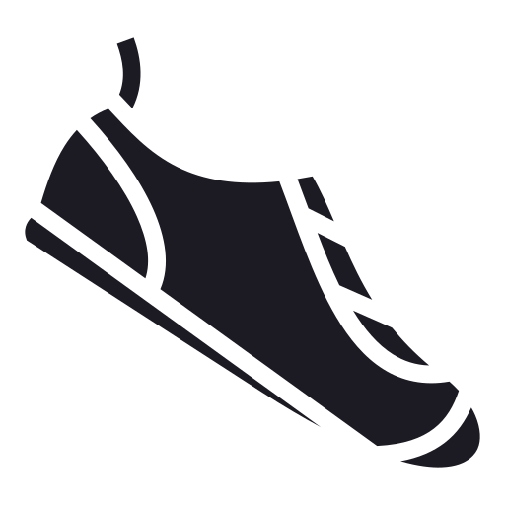  White trainers  LABEL: SHOE | Black trainers  LABEL: SHOE | Running trainers  LABEL: SHOE | Trainers with laces  LABEL: SHOE
Light-up trainers  LABEL: SHOE | Football trainers  LABEL: SHOE | Hi-top trainers  LABEL: SHOE | Slip-on trainers  LABEL: SHOE

Test photos (new)
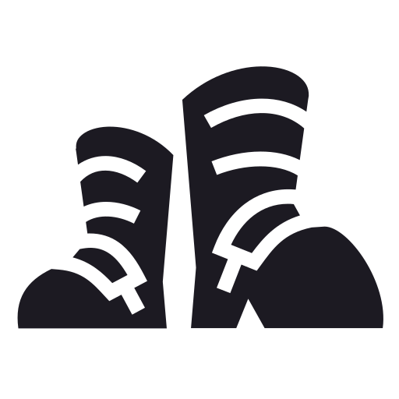  Wellies  ShoeSpotter predicts: __________ | 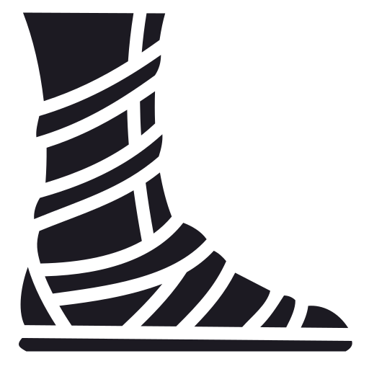  Sandals  ShoeSpotter predicts: __________ | 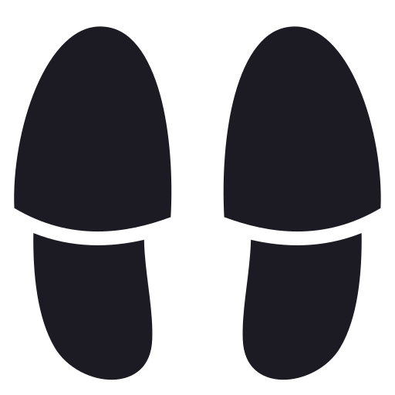  Slippers  ShoeSpotter predicts: __________
  Leather boots  ShoeSpotter predicts: __________ | 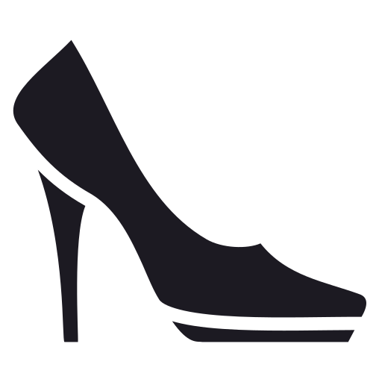  High heels  ShoeSpotter predicts: __________ | Trainers (new pair)  ShoeSpotter predicts: __________

Teacher answers: ShoeSpotter says NOT A SHOE for wellies, sandals, slippers, leather boots and high heels (no laces or thick rubber sole like its training photos), and SHOE for the new trainers.

Appendix B: Story cards: Joy Buolamwini
One set per group. Cut out and shuffle. Facts from published sources (checked October 2026). No images of faces.
1. A student with a project  Joy Buolamwini is a computer scientist. As a student at MIT, a university in the USA, she built an art project that used face-detection software made by other people. | 2. The software didn't see her  The software did not detect Joy's face. Joy has dark skin. When she held up a plain white mask, the software detected the mask straight away.
3. Was it just her?  Joy wondered if this happened to other people. In 2018 she and another researcher, Timnit Gebru, tested face-analysis systems from big technology companies. | 4. What she found  The systems made far more mistakes for women with darker skin (up to about 1 in 3 wrong) than for men with lighter skin (fewer than 1 in 100 wrong).
5. Why?  Photo collections used to build and test systems like these had far more lighter-skinned faces. Not enough variety, so the systems worked less well for people who were left out. | 6. Speaking up  Joy published her results and spoke up. Several companies improved their systems. She started the Algorithmic Justice League to help make AI fairer for everyone.

Appendix C: Fishbowl observer sheet
Outer circle. Tally each time you hear a build or a challenge, and write one example.
Name (inner circle) | Builds (tally) | Best example I heard

 | Challenges (tally) | Was it backed with evidence? Example

My feedback: I noticed ___ built on ___'s idea by ___. One thing to try next time: ___.
______________________________________________________________________________________
______________________________________________________________________________________

Appendix D: Fishbowl question cards
Use two per round.
Question 1  Is it unfair that the systems worked less well for some people? Why? | Question 2  Whose job is it to fix it: the company, the people who chose the data, or the people using it?
Question 3  Should a system be used before it has been tested on everyone? | Question 4  Is a face system failing worse than ShoeSpotter failing? Why?
Question 5  What would you say to a company that made an unfair system? | Question 6  Joy spoke up. Why is speaking up important?

Appendix E: Fix-It plan
One per group.
 | ShoeSpotter | Face-analysis systems
Who was left out?
Fix 1 and why it would help
Fix 2 and why it would help
Fairness Scale now (circle one) | FAIR / FAIR IF… / UNFAIR | FAIR / FAIR IF… / UNFAIR

Fix menu: more variety in the training data · test with everyone before use · ask the people affected · say what it can't do · a person checks important decisions · don't use it until it's fair

  FAIR  Works well for everyone it affects. |   FAIR IF…  Only fair if something changes. |   UNFAIR  Leaves people or the planet worse off.

Appendix F: Talk frame cards
Support: full frame + word bank
This is unfair because ___ was left out of the training data.
One way to fix it is ___.
Word bank: unfair · left out · training data · variety · works less well for · test · everyone · fix · responsible
Core: sentence starters
Building on ___'s idea, ___.
That's a fair point, but the evidence suggests ___.
To summarise our discussion, ___.
Stretch: open reasoning
I'd challenge that, because if ___ then ___. A fairer design would ___.
Although ___, I think ___ matters more because ___.

Appendix G: Watchdog Report exit tickets
WATCHDOG REPORT · BRIEF 3 · SEAL: FAIRNESS FINDER
Name: ___________________________
1. Why did ShoeSpotter fail? Use "training data": ______________________________________
2. What did Joy Buolamwini find? ______________________________________________
3. One way to make an AI fairer is ___ because ___.
______________________________________________________________________________________
Talk check: I built on or challenged an idea with evidence ☐

WATCHDOG REPORT · BRIEF 3 · SEAL: FAIRNESS FINDER
Name: ___________________________
1. Why did ShoeSpotter fail? Use "training data": ______________________________________
2. What did Joy Buolamwini find? ______________________________________________
3. One way to make an AI fairer is ___ because ___.
______________________________________________________________________________________
Talk check: I built on or challenged an idea with evidence ☐

Adapted from: OECD / European Union (2026), "Empowering learners for the age of AI: An AI literacy framework for primary and secondary education", https://doi.org/10.1787/65cd27d4-en (CC BY 4.0). This is an adaptation of an original work by the OECD and the European Union. The opinions expressed and arguments employed in this adaptation should not be reported as representing the official views of the OECD, its Member countries or the European Union.
Icons: Font Awesome Free (CC BY 4.0), game-icons.net (CC BY 3.0), Phosphor and Lucide (MIT/ISC), Material Design Icons (Apache 2.0). No AI-generated images are used.

