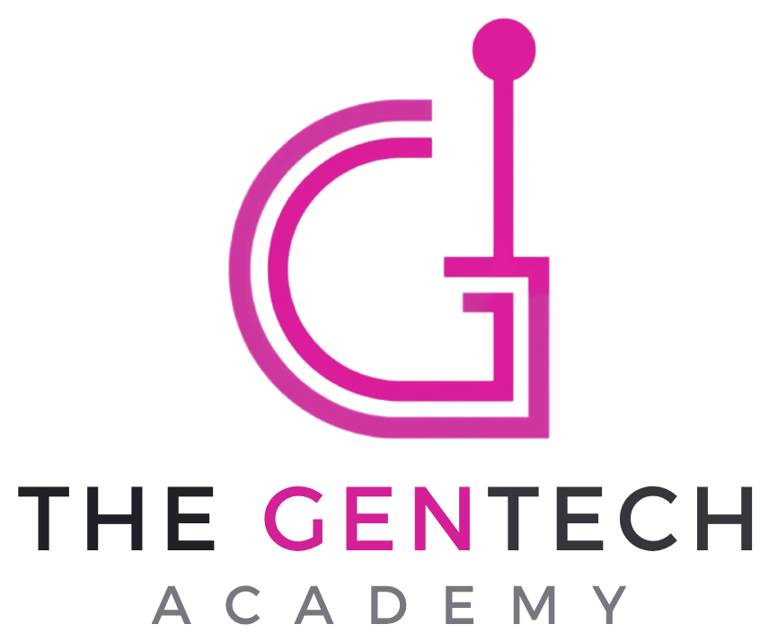
 YEAR 3 · AI LITERACY · UNIT OVERVIEW
Can We Trust AI?
Big question: When does AI help, when does it get things wrong, and who decides?
Pupils become AI Inspectors. In six "inspections" they test when AI can be trusted: choosing the right tool for a job, deciding what kind of problem AI could (and should) help with, checking an AI's maths answers, thinking about artists whose work AI copies, and judging when AI is used to help or to harm. Each inspection earns a stamp in their Inspector's Logbook, and the Trust-o-Meter (trust it · check it · don't trust it) runs through every lesson. The unit ends with the class writing, presenting and voting on its own Class AI Charter: the oral assessment. Everything is unplugged or teacher-led: Year 3 pupils never use AI tools themselves.

Unit at a glance
Year group / length | Year 3 · 6 lessons of 45–60 minutes (one half-term). Every plan has 60- and 45-minute timings
AILit focus (Basic) | MA1 · MA3 · EA3 · CA4 · EA7 (all at Basic). This matches the Year 3 column of the coverage matrix in the progression map; no matrix change is needed
National Curriculum | Computing KS2 (be discerning in evaluating digital content; select and use software to accomplish given goals; decompose problems; use technology safely, respectfully and responsibly; recognise acceptable and unacceptable behaviour; ways to report concerns) · Maths Y3 (column addition and subtraction; estimate and use inverse operations to check) · Art and design KS2 · English spoken language (Y1–6) · RSHE (online relationships; internet safety and harms) · PSHE/citizenship (making and changing rules)
2028-ready | Anticipates the new Computing strands on AI and data awareness and on digital literacy and responsible use. Rechecked 6 October 2026: draft programmes of study not yet published (final curriculum expected spring 2027, first teaching September 2028)
Trust values | Democracy and Honesty (unit focus) · Caring for others · Self-help · Social responsibility · Equity · Solidarity
AI access | No pupil use of AI (KS2, Trust policy). Every lesson has a fully unplugged route. Optional teacher-only demos on a Trust-approved tool (rehearsed, labelled, no personal data) in Lessons 1, 2 and 3; Lesson 4 uses one AI image prepared by the teacher in advance (or a hand-drawn copy instead)
DSL flags | Lesson 5: tell your DSL before teaching (recommended). Scenarios include AI used to write an unkind message and an AI-changed photo of a classmate (KCSIE 2026 conduct and content). No other lesson needs a DSL heads-up
Prior learning | Year 1 "Is It AI?" and Year 2 "How Do Machines Learn?" (AI is a tool made by people; it can get things wrong; check with an adult, a book or what you know). Schools new to the scheme: Lesson 1 works as a starting point
Next steps | Year 4 "AI Detectives" (what AI systems are designed to do; rules vs learning; recommendations; chatbots aren't friends; prompts). The Class AI Charter travels with the class

Lesson sequence
# | Lesson & key question | AILit | Main activity | Talk routine
1 | The Right Tool for the Job  Is AI always the best tool? | MA1 B | Real toolbox "wrong tool" hook; agree the Inspectors' Talk Code; Toolbox Challenge (match 12 tasks to tools incl. a person and me); Trust-o-Meter | Talk partners: Say it – Swap it
2 | What Kind of Problem?  Could AI help, and should it? | MA3 B | Help Desk letters; data / feelings / creative; could vs should (birthday poem demo); Could–Should sort | Agree–Build–Challenge introduced; trio roles
3 | Maths Checkers  Is the AI's answer right? | EA3 B | MathsBot's homework (labelled pretend AI answers); teacher think-aloud; Inspector's Bench; optional live check | Checking pairs with think-aloud (first, then, so)
4 | Who Made This?  Is it fair for AI to copy artists? | CA4 B | Original vs copy; how AI learns styles; Style Copier challenge; hot-seat Ama the artist and Jay the seller; Credit or Copy? sort | Hot-seating
5 | Good Use or Bad Use?  Does it depend on the person using it? | EA7 B ⚠ DSL | Same tool, two stories; "it depends on…" factors; helpful ↔ harmful washing line in two rounds | Talk detectives (inside–outside groups)
6 | Our Class AI Charter  What rules should we agree? | Review ★ | Letter from the Head; evidence wall; draft rules by theme; envoys; present and vote; sign the charter | Envoys ★
Each lesson follows a different structure (challenge game; card sort and discussion; maths investigation; role-play interview and making; physical continuum with talk detectives; democratic assembly), so no two lessons feel the same.

AILit Framework coverage
Code | Competence (unit focus) | Level | Lessons
MA1 | Decide whether to use AI: match tools (including AI) to the tasks they are designed for | Basic | 1 (focus), 2, 6
MA3 | Decompose: sort problems into data, feelings or creative, and discuss whether AI could or should help | Basic | 2 (focus), 6
EA3 | Accept, revise or reject: check an AI answer against a taught method (right, partly right, wrong) | Basic | 3 (focus), 6
CA4 | Authenticity and IP: AI can copy creative work, and why that matters to artists | Basic | 4 (focus), 5, 6
EA7 | Ethics and values: whether AI use helps or harms depends on its design and the user's intentions | Basic | 5 (focus), 4, 6
Knowledge statements used: K1.1, K1.4, K2.2, K3.1, K3.2, K4.1, K4.3. Skills: Computational Thinking, Problem Solving, Collaboration, Critical Thinking, Self & Social Awareness, Communication. Attitudes: Innovative, Responsible, Adaptable, Empathetic, Reflective. EA2 (accurate, non-human language) is modelled throughout via the power words.

Assessment
- Every lesson: an AfL hinge question, plus an "Inspector's Log" exit ticket with a talk check. Pupils stamp their Inspector's Logbook.
- Lesson 6: ★ oral assessment during the envoy round and charter presentations, using a rubric covering AILit content and the four Oracy Framework strands, with a class tracker and pupil self-assessment (Lower KS2 oral assessment: group talk and explaining to a new audience).
- Judgements: working towards / expected / greater depth against the "I can" statements below (from the progression map).
AILit | I can… | Assessed in
MA1 | match different tools (including AI) to the tasks they are designed for. | L1, L6
MA3 | sort problems into types (data, feelings, creative) and discuss whether AI could, or should, help. | L2, L6
EA3 | compare an AI answer with what I've been taught and decide whether it is right, partly right or wrong. | L3, L6
CA4 | explain that AI can copy or imitate people's creative work, and why that matters for artists. | L4, L6
EA7 | recognise that whether AI use is good or harmful depends on its design and the user's intentions. | L5, L6
Oracy | build on and politely challenge others' ideas, explain a process step by step, and explain a rule clearly to a new audience. | All; L6 ★

Oracy in this unit
Talk is central to every lesson. Each lesson uses a different Lower KS2 talk routine and tiered sentence frames: support (a full frame plus a word bank), core (a starter) and stretch (an open reasoning prompt). Frames are shown on the slides and printed as cards. Every plan includes a teacher-modelled example of the talk. The class agrees the Inspectors' Talk Code (five talk ground rules with gestures) in Lesson 1, revisits it every lesson with a focus rule, and adds it to the Class AI Charter in Lesson 6. Agree–Build–Challenge is introduced in Lesson 2 and used all unit; talk detectives (Lesson 5) and envoys (Lesson 6) complete the Lower KS2 routines. The printable Talk Toolkit (Y3-talk-toolkit.docx) gathers every frame by talk function.
Oracy strand | Unit progression
Physical | Gesture to show the steps of a check (L3) → projecting to a new group as an envoy and presenting a rule (L6 ★)
Linguistic | "because" to justify a choice (L1); sequencing with first, then, so (L3); accurate, non-human words for AI (power words, all lessons)
Cognitive | Agree, build and challenge with reasons (L2); clear, open questions in the hot-seat (L4); "it depends on…" reasoning (L5); justifying with evidence (L6)
Social-emotional | Listening to understand (Say it – Swap it, L1); trio roles (L2); bringing everyone in and kind, specific feedback as a talk detective (L5); group roles and envoys (L6)

Key vocabulary (unit glossary)
Word | Meaning
tool / designed | Something we use to do a job / planned and made by people for a particular job.
AI tool | A computer program trained on lots of examples so it can predict, sort or create things.
chatbot | An AI tool that writes replies by predicting which words come next.
data / feelings / creative problem | A problem about facts and numbers / about people and emotions / about making something new.
could / should | Is AI able to? / Is it a good idea, and whose job is it?
check / estimate / inverse | Make sure it's right another way / a sensible rounded guess / the opposite operation.
accept / revise / reject | Keep it (we checked) / fix the wrong part / don't use it.
original / copy / style | Made by the person who thought of it / made to look the same / an artist's special way of drawing.
credit / permission | Saying who made it / asking first and being told yes.
helpful / harmful | Makes things better for people / hurts people or makes things worse.
intention / it depends | What a person means to do / the answer changes with the situation.
charter / envoy / evidence | Rules a group agrees / someone sent to share ideas with another group / facts that show something is true.
Power words (use these): AI is a tool · designed by people · predicts · matches patterns · was trained on examples · can be wrong · check it. Avoid for AI: "the AI thinks / knows / understands / wants / feels / is always right". Teachers model this all unit (progression map, banned-phrase list).

Common misconceptions across the unit
Pupils may think… | What we teach
AI is the best tool for everything. | AI tools are designed for some jobs; a ruler, a person or my own brain is sometimes better (L1).
If AI can do it, we should let it. | Could isn't should. Feelings problems need people; my work should be mine (L2).
If a computer says it confidently, it's right. | AI predicts likely answers and can be wrong. Confident isn't correct: check (L3).
AI makes pictures out of nothing. | It learned from pictures people made, often without asking them, and can copy styles (L4).
AI is good or bad. | It depends on how it's designed and how people use it. AI doesn't want anything (L5).
Rules are made by adults for children. | Everyone can help make fair rules; rules can change by discussion and voting (L6).

Teacher subject knowledge (summary)
- AI as one tool among many (MA1): a chatbot predicts words; it can't see or measure our classroom, can't care, and shouldn't make decisions that belong to people. AI also hides inside map apps, translators and search engines.
- Could vs should (MA3): decomposing a problem means working out what kind it is. AI is strongest on data problems with lots of examples; it can generate words and pictures, but it doesn't feel, and it can't make something yours.
- Checking outputs (EA3): language models predict digits rather than calculate, so they can be wrong while sounding certain (K3.2). Year 3 pupils check with a taught method: estimate, column method, inverse. Verdicts: accept, revise, reject.
- Creators and copying (CA4): image generators are trained on huge numbers of pictures, many made by artists who weren't asked (K2.2). Year 3 key ideas: original, copy, style, credit, permission. The lesson uses a fictional artist so no real artist is imitated.
- Helpful or harmful (EA7): design and intention decide whether an AI use helps or harms (K4.1, K4.3). Factors: why, design, honesty, permission, a person checks.
- Each lesson plan has a fuller "Teacher subject knowledge" section and an optional extension for computing specialists.

Preparation checklist
Lesson | Prepare
1 | A real toolbox (hammer, ruler, scissors, tape, calculator, dictionary), tool and task cards, tool match sheets, Talk Code poster, Inspector's Logbooks (one per pupil, used all unit). Optional: rehearse the chatbot demo
2 | Three Help Desk letters in envelopes, problem cards, A3 Could–Should mats and ✓/✗ counters, ABC cards (one set per pupil) and tally strips. Optional: rehearse the poem demo
3 | MathsBot cards (labelled as pretend), check sheets, show-me verdict cards, place value counters, HTO mats, whiteboards. Optional: rehearse the live check
4 | Draw a Dotty Owl (style guide in the plan) and photograph it; prepare ONE labelled AI image (Trust-approved tool, style described in words, no artist names, nothing uploaded) OR a hand-drawn copy; props for Ama and Jay; scenario cards and signs
5 | Tell your DSL (recommended). Washing line, pegs and signs (or table lines), scenario and factor cards, talk detective sheets, worry box
6 | Head's letter (ideally signed), evidence wall of saved rule strips, theme cards, drafting sheets, envoy cards, A3 charter poster, rubric and tracker, self-assessments, certificates, dot stickers

Technology, Trust policy and safeguarding
- KS2 pupils do not use AI tools (Osborne Trust AI policy; scheme rule: no pupil AI use until Year 9). Pupils may suggest prompts or numbers; only the teacher types. No pupil log-ins are needed for any lesson.
- The teacher uses Trust-approved tools only (e.g. Copilot, Gemini), signed in with a Trust account, with no pupil names, photos or personal data in prompts. Training modes are opted out. Rehearse every demo and check the output for accuracy and bias first.
- Label all AI-generated content shown to pupils ("AI-generated"). Lesson 3's MathsBot answers are teacher-written and labelled as pretend, so no made-up content is presented as real AI output. The slides and worksheets contain no AI-generated images (icons only).
- Copyright and IP (Trust rule 6): never generate images that imitate a real, named artist, and never upload pupils' or anyone else's work to an AI tool (Lesson 4 uses a fictional artist and the teacher's own drawing).
- KCSIE 2026 categories in this unit: content (AI can be wrong or copy others' work: L3, L4), contact (chatbots can sound kind but can't care: L1, L2), conduct (using AI to be unkind or to change someone's photo: L5), commerce (selling AI copies of an artist's work: L4). Schools should also have AI chatbots and companion-style apps in their online-safety risk assessment.
- Lesson 5: tell your DSL before teaching (recommended). Keep discussion about made-up people, be alert to disclosures, follow your school's procedures and don't promise confidentiality.
- Many apps, chatbots and image tools are for 13+. If pupils mention using them, respond neutrally and focus on trusted adults and safe choices. Don't ask pupils to list the apps they use at home.

Guidance check (6 October 2026)
- National Curriculum: the current (2014) programmes of study remain statutory. The new Computing curriculum (strands: computer science; digital literacy and responsible use; AI and data awareness) is being drafted; final publication is expected in spring 2027 for first teaching in September 2028. No draft programme of study was found published at the time of this check.
- KCSIE 2026 (in force from 1 September 2026): contact risk includes harmful interactions with generative AI that simulates human interaction (chatbots and companion-style systems); conduct risk includes making, sending or receiving explicit images, including AI-generated ones (secondary content only in this scheme); annual filtering and monitoring reviews involving the DSL.
- DfE guidance: Generative AI in education and the Using AI in education support materials (updated May 2026) emphasise safe, purposeful use, data protection and checking outputs, all reflected in this unit's teacher-demo rules.
- Oracy: no national oracy framework has been published yet; the unit maps to the Oracy Framework strands and the English spoken language statements, as agreed in the brief.

Optional note for parents and carers
This half-term, Year 3 are "AI Inspectors". They're finding out when we can trust AI: choosing the right tool for a job, deciding which problems AI should and shouldn't help with, checking AI's answers in maths, thinking about artists whose work AI can copy, and learning that AI can be used to help or to harm, depending on the people who design and use it. They finish by writing their own Class AI Charter. Pupils won't use AI tools themselves in school. You might like to ask your child: "How do you know if an AI answer is right?" or "Should AI write a birthday card for Grandma? Why or why not?" Many AI apps and chatbots are designed for ages 13+. If your child sees AI at home, talking together about checking information, giving credit and telling a trusted adult if anything worries them is a great way to help.

Adapted from: OECD / European Union (2026), "Empowering learners for the age of AI: An AI literacy framework for primary and secondary education", https://doi.org/10.1787/65cd27d4-en (CC BY 4.0). This is an adaptation of an original work by the OECD and the European Union. The opinions expressed and arguments employed in this adaptation should not be reported as representing the official views of the OECD, its Member countries or the European Union.
Icons: Font Awesome Free (CC BY 4.0), game-icons.net (CC BY 3.0), Phosphor and Lucide (MIT/ISC), Material Design Icons (Apache 2.0). No AI-generated images are used.

