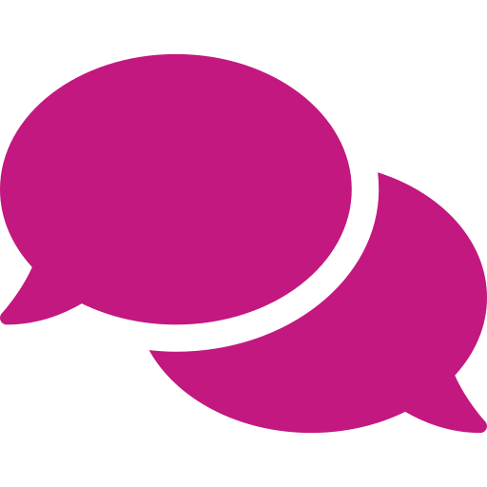 YEAR 3 · CAN WE TRUST AI? · TALK TOOLKIT
AI Inspectors' Talk Desk Mat
Talk function | Support (full frame) | Core (starter) | Stretch (open reasoning)
Explaining | I would use a ___ for this job because it can ___. | The best tool for ___ is ___ because ___. | ___ is a better choice than ___ here, because ___, even though ___.
Agreeing and building | I agree with ___ because ___. | I'd like to build on what ___ said. ___ | Adding to ___'s idea, another reason is ___, which means ___.
Challenging politely | I see it differently because ___. | I'm not sure that's right, because when I checked ___. | That's a good point, but have you thought about ___? It might mean ___.
Questioning | Why do you think ___? | How do we know that ___? | What would happen if ___? Would that change our answer?
Justifying with evidence | The AI's answer is ___ because when I checked, ___. | I know this because ___. | My evidence is ___. This shows ___, so I think ___.
Comparing | The ___ is good at ___ but the ___ is good at ___. | AI could help with ___, but a person is better at ___ because ___. | Both ___ and ___ can ___, whereas only ___ can ___ because ___.
Summarising | Our group thinks ___. | So, our group decided ___ because ___. | Most of us agreed ___, but some of us thought ___ because ___.
Reflecting | Now I know ___. | I changed my mind when ___. | I used to think ___. Now I think ___, because ___.

Inspectors' Talk Code   Listen to understand  Build on ideas 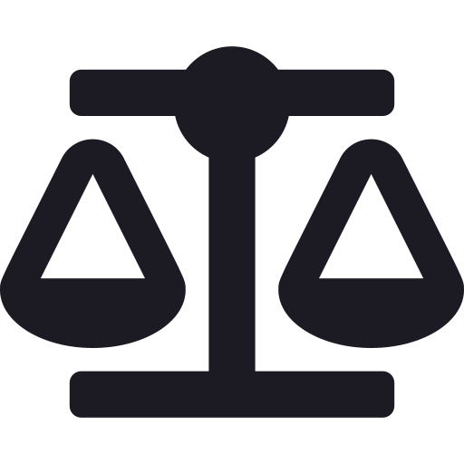 Challenge the idea, not the person  Give a reason  Bring everyone in | Power words for AI  Say: AI is a tool · designed by people · predicts · matches patterns · was trained on examples · can be wrong · check it  Don't say: the AI thinks · knows · understands · wants · feels · is always right
Word bank and lesson frames
  tool | 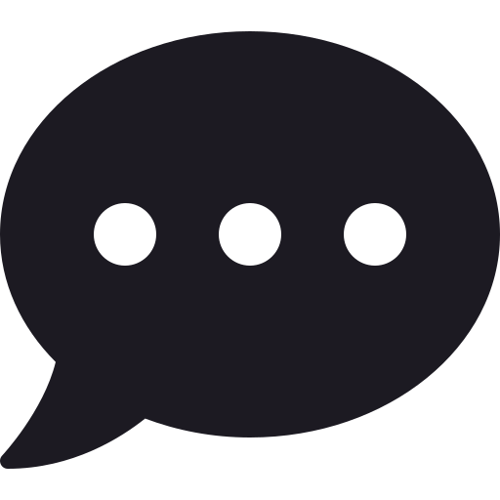  chatbot | predicts |   check |   revise |   credit |   permission | it depends |   helpful |   because

  Inspection 1: The Right Tool for the Job  tool · designed · task · digital · AI tool · chatbot · best  The best tool for ___ is ___ because ___. |   Inspection 2: What Kind of Problem?  data · feelings · creative · could · should · my own  AI could help with ___, but should it? I think ___ because ___. |   Inspection 3: Maths Checkers  check · estimate · inverse · column method · accept · revise · reject  First I ___. Then I ___. So the AI's answer is ___.
  Inspection 4: Who Made This?  artist · original · style · copy · credit · permission · copyright  I think the artist would feel ___ because ___. | 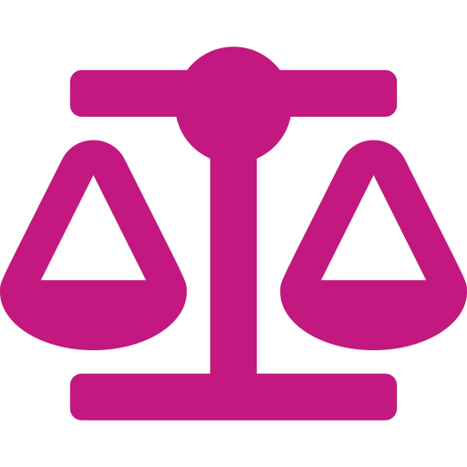  Inspection 5: Good Use or Bad Use?  helpful · harmful · intention · design · honest · it depends  It depends on ___ because ___. |   Inspection 6: Our Class AI Charter  charter · rule · evidence · envoy · vote · trust  Our rule is ___. We know this matters because in Inspection ___, we found ___.

Talk routine cards
Say it – Swap it (L1)  A says it; B repeats it back ("So you think…") then agrees or adds | 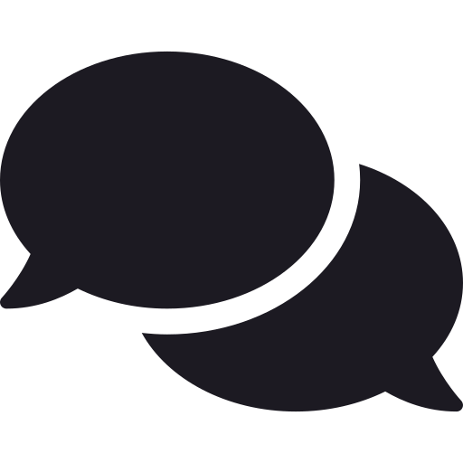  Agree–Build–Challenge (L2)  Respond with a card: agree, build or challenge, always with a reason |   Checking pairs (L3)  Checker works it out; Explainer explains: first, then, so |   Hot-seating (L4)  Ask one clear, open question; listen; ask a follow-up | Talk detectives (L5)  Watch one person, tally talk moves, give kind, specific feedback |   Envoys (L6)  Carry your group's ideas to another group; bring one suggestion back

Working wall: Inspectors' Talk Code
Listen to understand  (Cup a hand behind your ear) | Build on ideas  (Stack one fist on the other) | Challenge the idea, not the person  (Tilt a flat hand side to side) | Give a reason  (Tap your temple, then open your hand) | Bring everyone in  (Sweep an open palm towards your group)

Working wall: Agree · Build · Challenge
  AGREE  I agree with ___ because ___.  (Thumb up) | BUILD  I'd like to build on what ___ said. ___  (Stack fists) | CHALLENGE  I see it differently because ___.  (Tilt hand)

Working wall: the Trust-o-Meter
  TRUST IT  It's right, and I checked. Accept it. | CHECK IT  Partly right, or not sure yet. Revise or check again. |   DON'T TRUST IT  It's wrong, or not a good use. Reject it.

Inspection 1  Tool Picker | Inspection 2  Problem Sorter | Inspection 3  Answer Checker | Inspection 4  Credit Giver | Inspection 5  Fair Judge | Inspection 6  Charter Maker

Adapted from: OECD / European Union (2026), "Empowering learners for the age of AI: An AI literacy framework for primary and secondary education", https://doi.org/10.1787/65cd27d4-en (CC BY 4.0). This is an adaptation of an original work by the OECD and the European Union. The opinions expressed and arguments employed in this adaptation should not be reported as representing the official views of the OECD, its Member countries or the European Union.
Icons: Font Awesome Free (CC BY 4.0), game-icons.net (CC BY 3.0), Phosphor and Lucide (MIT/ISC), Material Design Icons (Apache 2.0). No AI-generated images are used.

