 YEAR 1 · IS IT AI? · TALK TOOLKIT
AI Explorer Talk Desk Mat
Talk function | Support (full frame) | Core (starter) | Stretch (open reasoning)
Explaining | This is a ___. It is a computer because ___. | I think ___ is AI because ___. | ___ is AI because it learned from ___ so it can ___.
Building | I agree with ___. | I agree with ___ because ___. | I agree with ___ and I want to add ___.
Challenging politely | I think something different. | I think something different because ___. | I can see why you said ___, but I think ___ because ___.
Questioning | Can you ___? | I wonder why ___. | I wonder what would happen if ___.
Justifying | I think ___ because ___. | I know it is ___ because ___. | I think ___ because ___, and also because ___.
Comparing | A person can ___. AI can't ___. | A person can ___ but AI can't ___. | People and AI can both ___, but only a person can ___ because ___.
Summarising | We found out ___. | My partner said ___. | The big idea is ___ because ___.
Reflecting | I learned ___. | Now I know ___. | I used to think ___, but now I think ___.

  computer |   AI |   examples |   guess |   rule |   person |   electricity |   private |   trusted adult |   because

Explorer Talk Rules   Look at the speaker  Listen carefully  Take turns  Use kind words Say "because" | Power words for AI  Say: AI is a tool · made by people · learned from examples · makes guesses · spots patterns · needs electricity  Don't say: AI thinks · feels · knows · wants · is my friend
Picture word bank and lesson frames
  Lesson 1: Robot or Not?  computer · instructions · electricity · machine · hidden  I think the ___ is a computer because ___. |   Lesson 2: Spot the AI  AI · example · guess · learn · hidden · tool  I can see AI in the ___. It can ___. | 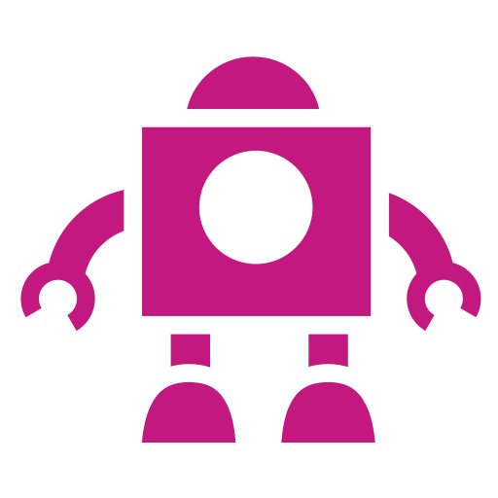  Lesson 3: Bossy Robots  rule · first · then · exact · stuck · algorithm  First, ___. Then, ___. The robot got stuck because ___.
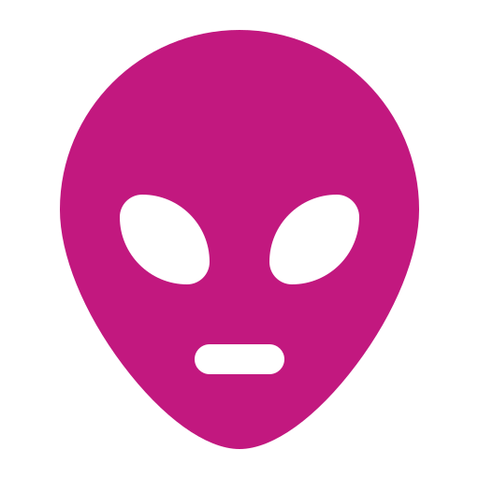  Lesson 4: Teach the Alien  learn · example · train · test · pattern · mistake  Zib thought it was a cat because it looked like ___. |   Lesson 5: Is AI a Person?  person · tool · feelings · private · trusted adult  Robo, do you ___? A person can ___ but AI can't ___. |   Lesson 6: Powered Up!  electricity · battery · plug · data centre · switch off  This is a ___. It is / isn't AI because ___. It needs ___ to work.

Talk routine cards
  Talk partners  Knees to knees. Take turns. "My partner said…" | I see / I think / I wonder  Describe, explain, then ask a question |   Boss and Robot  Boss instructs; Robot repeats, then follows | Think–pair–share  Think (count to 5), tell a partner, share |   Hot-seating  Ask one clear question; listen to the answer |   Show-and-tell  Stand tall, loud and clear, look at your audience

Working wall: Explorer Talk Rules
Look at the speaker  (Point two fingers at your eyes) | Listen carefully  (Cup a hand behind your ear) | Take turns  (Roll your hands over each other) | Use kind words  (Hand on heart) | Say "because"  (Tap your head, then open your hand)

Working wall: Agree · Something different · Wonder
  I AGREE  I agree with ___ because ___. | SOMETHING DIFFERENT  I think something different because ___. |   I WONDER  I wonder ___.

Adapted from: OECD / European Union (2026), "Empowering learners for the age of AI: An AI literacy framework for primary and secondary education", https://doi.org/10.1787/65cd27d4-en (CC BY 4.0). This is an adaptation of an original work by the OECD and the European Union. The opinions expressed and arguments employed in this adaptation should not be reported as representing the official views of the OECD, its Member countries or the European Union.
Icons: Font Awesome Free (CC BY 4.0), game-icons.net (CC BY 3.0), Phosphor and Lucide (MIT/ISC), Material Design Icons (Apache 2.0). No AI-generated images are used.

