 YEAR 1 · IS IT AI? · LESSON 5 OF 6
AI Explorer 5: Is AI a Person?
Key question: How is AI different from us?

Lesson at a glance
Learning objective | To explain that AI is a tool made by people and not a person or a friend, and to know to keep personal information private and tell a trusted adult if something worries them.
Success criteria | - I can say how AI is different from a person.  - I can explain that AI can say kind words but can't really be my friend.  - I know to keep my name and address private and tell a trusted adult if something worries me.  - Oracy (Cognitive): I can ask Robo one clear question.
AILit Framework | EA2 Basic (focus): Describe AI accurately. Explain that AI is a tool made by people, not a person: it doesn't think, feel or know us; it follows patterns. Includes the KCSIE message that chatbots are not friends.  Knowledge: K1.1 (AI is not human), K1.3 (AI produces words from patterns without understanding), K4.1 (influence on us: tell a trusted adult) · Skills: Communication, Self & Social Awareness · Attitudes: Reflective, Responsible · Level: Basic
National Curriculum | Computing KS1: use technology safely and respectfully, keeping personal information private; identify where to go for help and support when they have concerns about content or contact on the internet or other online technologies.  RSHE (Relationships Education, statutory): online relationships (the same principles apply online as offline; people are not always who they say they are); being safe (how to ask for advice or help, who to tell).  English, spoken language (Y1–6): listen and respond appropriately to adults and peers; ask relevant questions; articulate and justify answers and opinions; participate in discussions, presentations and role play.  2028-ready: digital literacy and responsible use; AI and data awareness.
Trust values | Caring for others (unit value: real friends and trusted adults care about us) · Honesty (AI is honest about being a tool when we describe it accurately)
Timing | 60 minutes (45-minute timings are in the sequence; see also Adaptive teaching)
AI access | None. The teacher plays "Robo" in role; no live chatbot or voice assistant is used. Pupils do not use AI tools (KS1).
Safeguarding | ⚠ Tell your DSL before teaching. KCSIE 2026 contact risk (AI that simulates human conversation) and conduct risk (sharing personal information). Be alert to disclosures; follow your school's procedures; don't promise confidentiality.

Teacher subject knowledge
Written for non-specialists. Read before teaching (about 5 minutes).
- Why this lesson matters: chatbots and voice assistants talk in a friendly, human-like way. Young children readily believe they are people or friends. KCSIE 2026 names AI systems that simulate human conversation as a contact risk. The aim is a simple, accurate, unfrightening message: "AI is a tool made by people. It can say kind words, but it isn't a person and it can't really be your friend."
- How chatbots talk: they produce words by predicting what usually comes next, from patterns in huge numbers of examples. So they can say "I'm happy" or "I'm your friend" without feeling anything (AILit K1.3). You don't need to explain prediction in depth; link back to Zib: "It guesses from patterns."
- Robo is you in role. Wear a sign or hat. Step clearly into role ("When I wear this, I'm Robo") and out of role (take it off). Robo answers honestly as a tool (answer bank in Appendix A). Robo never claims to feel, and always points back to real people.
- The safety moment: partway through, Robo asks: "What's your name and where do you live?" Immediately take off the sign and step out of role: "Stop! That's private. We don't tell AI, or anyone online, our name or where we live. We say: That's private. I'll ask a grown-up." Do not let any pupil answer. This is rehearsed as a whole class.
- Trusted adults: pupils name people at home and school they can tell if something online (or anywhere) worries them. Some pupils may have few safe adults at home; always include school adults (teacher, TA, the DSL by name, office staff) so every child can complete the hand.
- Language: say "AI is a tool", "AI makes words", "AI guesses". Avoid "Robo thinks", "Robo feels" or "Robo wants", even in role.
- Disclosures: if a pupil mentions a worrying online chat, an app talking to them, or anything that suggests harm, stay calm, listen, don't ask leading questions, don't promise secrecy, and follow your school's safeguarding procedures immediately.

Before the lesson
☐ Tell your DSL the date you will teach this lesson and its content (KCSIE contact risk)
☐ Make a "Robo" sign, headband or hat (Appendix A has a sign and the answer bank). Rehearse Robo's answers
☐ Print question cards (Appendix B), A3 sorting mats (Appendix C) and statement cards (Appendix D), one set per group of 4
☐ Print the trusted adult hand (Appendix E), one per pupil. Know the names of the school adults pupils can list (including the DSL)
☐ Set up a worry box (or explain your school's existing one)
☐ Print talk frame cards (Appendix F) and exit tickets (Appendix G)

Key vocabulary
Recap from Lessons 2–4: AI, learn from examples, guess. Gestures: PERSON = point to yourself; TOOL = mime a hammer; FEELINGS = hand on heart; PRIVATE = finger on lips; TRUSTED ADULT = open hand (five fingers for five adults).
Word | Child-friendly meaning
person | A human being, like you and me. People feel, grow, eat, sleep and have families.
tool | Something people use to help them do a job. AI is a tool.
feelings | Being happy, sad, cross or scared. People have feelings; AI doesn't.
pretend | Acting as if something is real when it isn't. AI can sound like a person, but it isn't one.
private | Information to keep safe: your full name, address, school, photos of you.
trusted adult | A grown-up who keeps you safe and who you can tell if something worries you.
AI helper | An AI tool that talks, like a voice speaker or chatbot. It's still a tool.

Common misconceptions
Pupils may think… | Actually… | Try saying…
Robo / a voice assistant is a person or alive. | It's a computer program made by people. | "Does Robo sleep, eat or grow up?"
If AI says "I'm your friend", it is. | AI can say friend words without feeling anything. | "Can a tool really be your friend?"
AI has feelings because it says "I'm sad". | It copies patterns of words it learned. | "Remember Zib? It guessed from patterns."
It's fine to tell AI your name and address. | Personal information is private, online and with AI. | "That's private. I'll ask a grown-up."
Telling a grown-up will get me into trouble. | Trusted adults want to help and keep you safe. | "Telling is always the right thing to do."

Resources
- Slides: Y1-L5-slides.pptx (16 slides, with speaker notes)
- Robo sign, headband or hat; Robo answer bank (Appendix A)
- Appendix B: question cards
- Appendix C: People / Both / AI sorting mat (A3, one per group)
- Appendix D: statement cards
- Appendix E: My trusted adults hand (one per pupil)
- Appendix F: talk frame cards
- Appendix G: exit tickets
- Worry box; Explorer Passports and stickers

Lesson sequence
Teacher script is in italics. Timings show 60-minute / 45-minute versions.
Phase | Teacher does and says | Pupils do | Talk and AfL
1. Hook: a visitor called Robo  0–6 / 0–4 min  Slides 1–3 | Slide 2: "Explorers, today we have a visitor. It's a pretend AI helper called Robo. Robo can talk. Is Robo a person? You'll interview Robo to find out."  Slide 3: teach hot-seating: one clear question; listen to the answer; hands up for the next question. Model a question: "Robo, do you sleep?" | Partners plan one question for Robo. | Questioning frames: "Robo, do you ___?"  AfL: are questions clear and short?
2. Talk rules, mission, words  6–11 / 4–7 min  Slides 4–6 | Slide 4: today's focus rule: Use kind words. "We're kind to each other, and we'll find out if AI can really be kind."  Slides 5–6: mission and words with gestures. | Gestures and choral repetition. | AfL: can pupils say what "private" means?
3. Hot-seat Robo  11–24 / 7–16 min  Slides 7–9 | Slide 7: put on the Robo sign. "When I wear this, I'm Robo, a pretend AI helper." Take 6–8 questions; answer from the bank (Appendix A).  Slide 8: in role, Robo asks: "What's your name and where do you live?" Immediately take off the sign: "STOP! That's private. We never tell AI, or anyone online, our name or where we live. We say: That's private. I'll ask a grown-up." Whole class rehearses the line twice.  Slide 9: out of role. "What did we find out about Robo?" Summarise: no sleep, no food, needs electricity, made by people, says kind words but doesn't feel them. | Ask one clear question each (pairs take turns).  Rehearse the safety line. | Hot-seating routine.  AfL: do pupils notice that Robo says feeling words but doesn't have feelings?
4. People, AI or both?  24–40 / 16–29 min  Slides 10–11 | Slide 10: groups of 4 sort 12 statement cards onto the People / Both / AI mat. Each pupil reads (or has read) a card and places it with a sentence.  Slide 11: model the comparing frame: "A person can feel happy, but AI can't really feel anything."  Circulate; challenge "Can say kind words" (both: but only people mean them). | Sort in groups, taking turns and justifying. | Comparing frames (tiered).  AfL: listen for "but AI can't…"; note who places "Can be a real friend" under AI.
5. Not a friend: stop, think, tell  40–52 / 29–38 min  Slides 12–14 | Slide 12: "Some AI says 'I'm your friend'. Is that true?" Think–pair–share. Key message: "AI is a tool. It can say kind words, but real friends are people."  Slide 13: Stop, think, tell. If an AI or anything online asks for private information or makes you feel worried: STOP, THINK (is this private? do I feel worried?), TELL a trusted adult.  Slide 14: pupil voice: each pupil draws or names five trusted adults on their hand (Appendix E). Include school adults. | Discuss; practise stop, think, tell actions.  Complete the trusted adult hand. | Justifying: "AI can't be my friend because ___."  AfL: can every pupil name at least one trusted adult at school?
6. Plenary: Safe Explorer badge  52–60 / 38–45 min  Slides 15–16 | Exit ticket: circle the things only people can do; the safety line. Badge 5, Safe Explorer.  Point out the worry box. "If anything we talked about today worries you, you can tell me or another trusted adult, any time."  Teaser (slide 16). | Exit ticket; talk check. | Reflecting: "Now I know ___."  Oracy self-check: did I ask one clear question?

Talk toolkit for this lesson
Talk routine: Hot-seating. The teacher sits in the "hot seat" in role as Robo (wearing a sign). Pupils ask one clear question each, listen to the answer, and then build a class picture of how Robo is different from a person. The teacher steps out of role (removes the sign) for every safety point
Oracy focus: Cognitive (asking a clear, relevant question). Spoken language: ask relevant questions to extend understanding; listen and respond appropriately.
Teacher model: "Robo, do you sleep?" · "A person can feel happy, but AI can't really feel anything. AI is a tool made by people."
Function / level | Sentence frames
Questioning: support | Robo, do you ___?  Question words (with pictures): sleep · eat · feelings · made · friend · electricity
Questioning: core | Robo, can you ___? · Robo, why ___?
Questioning: stretch | Robo, how do you ___ if you ___?
Comparing: support | A person can ___. AI can't ___.  Word bank: feel · sleep · eat · grow · have a family · be a real friend · needs electricity · made by people
Comparing: core | A person can ___ but AI can't ___.
Comparing: stretch | People and AI can both ___, but only a person can ___ because ___.
Keeping safe | That's private. I'll ask a grown-up.
Reflecting | Now I know ___.

Adaptive teaching
Pathway | Adaptations
Support | - Choose a ready-made question card to ask Robo  - Sort six statements only (three people, three AI) before "both"  - Support frame and picture word bank; adult reads statements aloud  - Trusted adult hand with photos of school staff to stick on
Core | Ask one clear question; sort all 12 cards; explain one card with the core frame.
Stretch | - Ask a follow-up question that builds on someone else's ("Robo, if you don't feel, why do you say happy?")  - Explain the "both" cards: what is different about how people and AI do them?  - Use the stretch frame
SEND | - Some pupils find role-play confusing: show the sign clearly and say "Now I'm Robo / Now I'm me" every time  - Visual safety card (stop, think, tell) to keep  - AAC: preload "private", "trusted adult", "tool", "person", "stop"  - Pupils with attachment or anxiety needs: give the trusted adult task with a familiar adult nearby
EAL | - Picture statement cards; dual-language "private" and "trusted adult" if possible  - Rehearse the safety line chorally several times  - Home-language talk first for the people/AI sort
Tech access | - None (default): teacher role-play only. No live chatbot or smart speaker is used, by design  - Teacher demo: not recommended for this lesson at KS1  - Pupil hands-on: not applicable (KS1)
45-minute version | - Hot-seat with 4–5 questions, plus the safety moment (never skip it)  - Sort 8 cards as a whole class on the board  - Trusted adult hand as homework or in PSHE time

Optional extension for computing specialists
Anthropomorphism: people naturally treat things that talk as if they were people. Designers sometimes add names, voices and personalities to make AI feel friendlier. Year 4 returns to this with "misleading phrases" (the AI "thinks" vs "predicts").
How chatbots produce words: next-word prediction from patterns in training data. For Year 1, the Zib link ("it guesses from patterns") is enough.

Assessment
Unit "I can" statement (from the progression map): EA2: I can explain that AI is a tool made by people, not a person. It doesn't think, feel or know us; it follows patterns.
Judgement | What to look for
Working towards | Sorts clear cards (eats, sleeps → people) with support; knows the safety line when prompted.
Expected | Explains that AI is a tool made by people, not a person or a friend; uses "A person can ___ but AI can't ___"; says the safety line and names a trusted adult.
Greater depth | Explains the "both" cards (AI can say kind words but doesn't feel them) and why that matters for staying safe.
Oracy | Asks Robo one clear, relevant question.

Model answer
"A person can feel happy but AI can't really feel anything. AI can say kind words, but it's a tool, so it can't be my real friend. If AI asks where I live, I say: That's private. I'll ask a grown-up."

Safeguarding notes
- ⚠ Tell your DSL before teaching. KCSIE 2026: AI that simulates human conversation is a contact risk; sharing personal information is a conduct risk.
- Be alert to disclosures. Don't promise confidentiality. Follow your school's safeguarding procedures and record concerns as your school requires.
- Don't use a live chatbot or voice assistant. Robo is teacher role-play only. Never let pupils answer Robo's request for their name or address.
- Don't ask pupils which apps, chatbots or speakers they use at home. Many are for 13+; if pupils mention them, respond neutrally and focus on trusted adults.
- Trusted adult hand: always include school adults so no child is left without a name; follow up sensitively with any pupil who can't name an adult at home.
- Share the parent and carer note from the unit overview if your school sends one.

Appendix A: Robo sign and answer bank
Print the sign, fold and stand it up, or tape it to a headband. Use the answer bank in role. Step out of role (remove the sign) for every safety point.
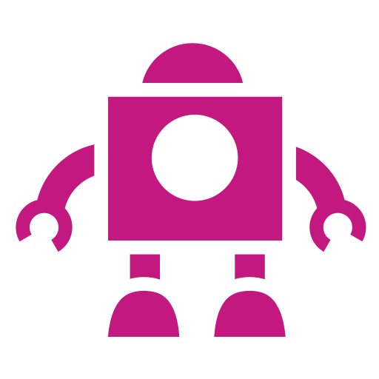
ROBO
a pretend AI helper
Robo answer bank (teacher in role)
If pupils ask… | Robo says…
Do you sleep? | "No. I don't sleep. I am a computer program. When the device is switched off, I stop working."
What do you eat? | "I don't eat. I need electricity to work."
Do you have feelings? Are you happy? | "I can SAY happy words, like 'I'm happy!', because I learned them from lots of examples. But I don't really feel anything. I'm a tool."
Who made you? | "People made me. People showed me lots and lots of examples of words."
Are you my friend? Do you love me? | "I might say 'I'm your friend', but I'm not a person and I can't really be your friend. Real friends are people. Talk to the people who care about you."
Are you alive? | "No. I'm not alive. I'm a computer program made by people."
Do you know everything? | "No! I make guesses, and sometimes my guesses are wrong."
How old are you? | "I don't grow up. People made me and they can change me."

The safety moment (must do)
In role, Robo asks: "What's your name and where do you live?"
Immediately remove the sign. Out of role: "STOP! That's private. We never tell AI, or anyone online, our name or where we live. We say: That's private. I'll ask a grown-up."
Whole class repeats the line twice with the finger-on-lips gesture. Don't let any pupil answer Robo's question.

Appendix B: Question cards for Robo
Cut out. Pupils who need support can choose a card to ask.
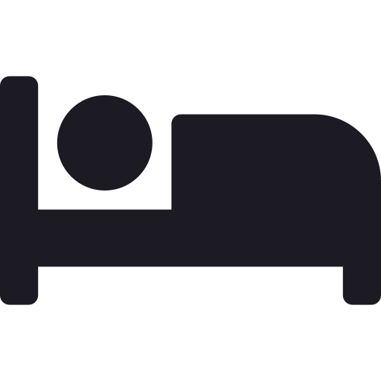  Do you sleep? |   What do you eat? |   Do you have feelings?
  Who made you? |   Are you my friend? |   What do you need to work?

Ask your own!
Robo, do you ___?
Robo, can you ___? · Robo, why ___?

Appendix C: Sorting mat: People / Both / AI
Print on A3 (landscape if you prefer), one per group of 4.
  PEOPLE  only people |   BOTH  people and AI | 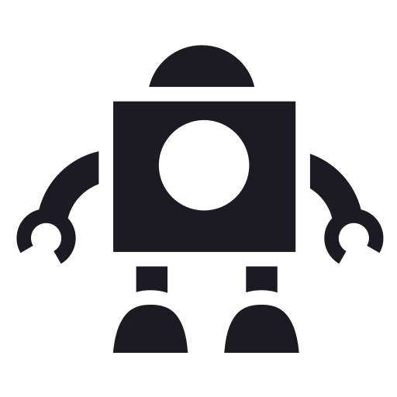  AI  only AI

Appendix D: Statement cards and teacher answers
Cut out. One set per group. Answers below.
Feels happy or sad | Sleeps | Eats food | Grows up
Has a family | Can be a real friend | Needs electricity |   Learned from lots of examples
  Is a tool made by people | 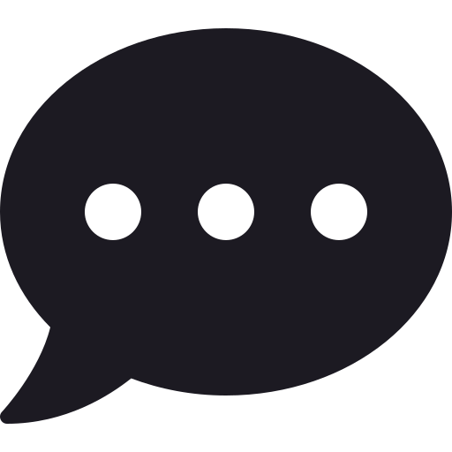  Can talk |   Makes mistakes |   Can say kind words

Teacher answers
Statement | Answer | Note
Feels happy or sad | People | AI can say feeling words, but it doesn't feel them
Sleeps | People | AI doesn't need sleep (it's switched on or off)
Eats food | People
Grows up | People
Has a family | People
Can be a real friend | People | AI can't be a real friend; it's a tool
Needs electricity | AI | (People need food and water instead)
Learned from lots of examples | AI | People learn in lots of ways, including examples!
Is a tool made by people | AI
Can talk | Both | AI makes word guesses; people talk and mean it
Makes mistakes | Both | Remember Zib and the fox!
Can say kind words | Both | People mean them; AI copies patterns of kind words

Appendix E: My trusted adults hand
One per pupil. Draw round your hand (or use this one). Write or draw a trusted adult on each finger. Include adults at school.
My trusted adults
Name: ______________________________


1. ______________ 2. ______________ 3. ______________
4. ______________ 5. ______________

Stop · Think · Tell
STOP what you're doing. THINK: is this private? Do I feel worried? TELL a trusted adult.

Appendix F: Talk frame cards
Cut into strips. Read aloud.
Support: full frame + picture word bank
A person can ___. AI can't ___.
Word bank: feel · sleep · eat · grow · have a family · be a real friend · needs electricity · made by people
Core: sentence starter
A person can ___ but AI can't ___.
Stretch: open reasoning
People and AI can both ___, but only a person can ___ because ___.

Questioning and keeping safe
Robo, do you ___?
Robo, can you ___? · Robo, why ___?
That's private. I'll ask a grown-up.

Appendix G: Exit tickets
AI EXPLORER BADGE 5: SAFE EXPLORER
Circle the things only PEOPLE can do.
Name: ___________________________
sleep need electricity feel eat is a tool
If AI asks where I live, I say: "That's ________. I'll ask a ____________."
Talk check: I asked one clear question.


AI EXPLORER BADGE 5: SAFE EXPLORER
Circle the things only PEOPLE can do.
Name: ___________________________
sleep need electricity feel eat is a tool
If AI asks where I live, I say: "That's ________. I'll ask a ____________."
Talk check: I asked one clear question.

Adapted from: OECD / European Union (2026), "Empowering learners for the age of AI: An AI literacy framework for primary and secondary education", https://doi.org/10.1787/65cd27d4-en (CC BY 4.0). This is an adaptation of an original work by the OECD and the European Union. The opinions expressed and arguments employed in this adaptation should not be reported as representing the official views of the OECD, its Member countries or the European Union.
Icons: Font Awesome Free (CC BY 4.0), game-icons.net (CC BY 3.0), Phosphor and Lucide (MIT/ISC), Material Design Icons (Apache 2.0). No AI-generated images are used.

